PheWASReportModel

Structural Report

Author: Dr. Nansu Zong  
Deepak Sharma

Revision: 0.1

|  |  |
| --- | --- |
| Mayo Clinic Health Sciences Research |  |
|  | Date: August 14, 2019 |

**Revision History**

|  |  |  |  |
| --- | --- | --- | --- |
| **Revision** | **Date** | **Reason For Changes** | **Author** |
| 0.2 | <date 2> | <release> | <Author name> |
| 0.1 | <date 1> | <draft> | <Author name> |
|  |  |  |  |

**Table of Contents**

1. Introduction 1

Purpose 1

Scope 1

Overview 1

1. FHIR::R4::Context 2

author[x] 2

1.1. Class Annotation_author[x] 2

Direct Known Superclasses 2

Attributes 2

1.2. Class author[x] 3

bounds[x] 3

1.3. Class bounds[x] 3

1.4. Class repeat_bounds[x] 3

Direct Known Superclasses 3

Attributes 4

effective[x] 4

1.5. Class effective[x] 4

1.6. Class Observation_effective[x] 4

Direct Known Superclasses 4

Attributes 4

value[x] 5

1.7. Class component_value[x] 5

Direct Known Superclasses 5

Attributes 5

1.8. Class Observation_value[x] 6

Direct Known Superclasses 6

Attributes 6

1.9. Class Reporter_value[x] 6

Direct Known Superclasses 6

Attributes 6

1.10. Class UsageContextValue 7

Direct Known Superclasses 7

Attributes 7

1.11. Class value[x] 7

2. FHIR::R4::Datatype 8

Datatype 8

2.1. Class Address 8

Direct Known Superclasses 8

Attributes 8

2.2. Class Annotation 9

Direct Known Superclasses 9

Attributes 9

2.3. Class Attachment 10

Direct Known Superclasses 10

Attributes 10

2.4. Class BackboneElement 11

Direct Known Superclasses 11

Attributes 11

2.5. Class boolean 11

Direct Known Superclasses 11

2.6. Class canonical 11

Direct Known Superclasses 11

2.7. Class code 11

Direct Known Superclasses 11

Attributes 12

2.8. Class CodeableConcept 12

Direct Known Superclasses 12

Attributes 12

Associations 12

2.9. Class Coding 12

Direct Known Superclasses 12

Attributes 13

2.10. Class ContactDetail 13

Direct Known Superclasses 13

Attributes 13

2.11. Class ContactPoint 13

Direct Known Superclasses 13

Attributes 14

2.12. Class date 14

Direct Known Superclasses 14

Attributes 14

2.13. Class dateTime 14

Direct Known Superclasses 14

Attributes 15

2.14. Class decimal 15

Direct Known Superclasses 15

2.15. Class Duration 15

Direct Known Superclasses 15

2.16. Class Element 15

Attributes 15

2.17. Class Extension 15

Direct Known Superclasses 15

Attributes 16

2.18. Class HumanName 16

Direct Known Superclasses 16

Attributes 16

2.19. Class id 16

Direct Known Superclasses 16

Attributes 16

2.20. Class Identifier 17

Direct Known Superclasses 17

Attributes 17

2.21. Class instant 17

Direct Known Superclasses 17

2.22. Class integer 18

Direct Known Superclasses 18

2.23. Class markdown 18

Direct Known Superclasses 18

2.24. Class Meta 18

Direct Known Superclasses 18

Attributes 18

2.25. Class Narrative 19

Direct Known Superclasses 19

Attributes 19

2.26. Class Period 19

Direct Known Superclasses 19

Attributes 19

2.27. Class positiveInt 20

Direct Known Superclasses 20

2.28. Class Quantity 20

Direct Known Superclasses 20

Attributes 20

2.29. Class Range 20

Attributes 20

2.30. Class Ratio 20

Direct Known Superclasses 21

Attributes 21

2.31. Class Reference 21

Direct Known Superclasses 21

Attributes 21

2.32. Class SampledData 21

Direct Known Superclasses 21

Attributes 21

2.33. Class SimpleQuantity 22

Direct Known Superclasses 22

2.34. Class string 22

Direct Known Superclasses 22

Attributes 22

2.35. Class time 22

Direct Known Superclasses 22

2.36. Class unsignedInt 22

Direct Known Superclasses 23

2.37. Class uri 23

Direct Known Superclasses 23

Attributes 23

2.38. Class UsageContext 23

Direct Known Superclasses 23

Attributes 23

2.39. Class xhtml 23

Direct Known Superclasses 23

Known other classes 24

3. FHIR::R4::Extension 24

Extension 24

3.1. Class DiagnosticReport-geneticsAnalysis 24

Direct Known Superclasses 24

Attributes 25

3.2. Class DiagnosticReport-geneticsAssessedCondition 25

Direct Known Superclasses 25

Attributes 25

3.3. Class DiagnosticReport-geneticsFamilyMemberHistory 25

Direct Known Superclasses 25

Attributes 25

3.4. Class DiagnosticReport-geneticsReferences 25

Direct Known Superclasses 25

Attributes 25

3.5. Class observation-geneticsAllele 26

Direct Known Superclasses 26

Attributes 26

3.6. Class observation-geneticsAminoAcidChange 26

Direct Known Superclasses 26

Attributes 26

3.7. Class observation-geneticsAncestry 26

Direct Known Superclasses 26

Attributes 26

3.8. Class observation-geneticsCopyNumberEvent 26

Direct Known Superclasses 26

Attributes 27

3.9. Class observation-geneticsDNARegionName 27

Direct Known Superclasses 27

Attributes 27

3.10. Class observation-geneticsGene 27

Direct Known Superclasses 27

Attributes 27

3.11. Class observation-geneticsGenomicSourceClass 27

Direct Known Superclasses 27

Attributes 27

3.12. Class observation-geneticsInterpretation 28

Direct Known Superclasses 28

Attributes 28

3.13. Class observation-geneticsPhaseSet 28

Direct Known Superclasses 28

Attributes 28

3.14. Class observation-geneticsVariant 28

Direct Known Superclasses 28

Attributes 28

4. FHIR::R4::Profile 28

4.1. Class DiagnosticReport-genetics 29

Direct Known Superclasses 29

Attributes 29

4.2. Class Observation-genetics 29

Direct Known Superclasses 29

Attributes 29

5. FHIR::R4::Resource 30

Auxiliary 30

5.1. Class Arm 30

Direct Known Superclasses 30

Attributes 30

5.2. Class Component 31

Direct Known Superclasses 31

Attributes 31

5.3. Class Contact 31

Direct Known Superclasses 31

Attributes 31

5.4. Class Objective 31

Direct Known Superclasses 31

Attributes 32

5.5. Class Organization 32

Direct Known Superclasses 32

Attributes 32

5.6. Class Patient 32

Direct Known Superclasses 32

Attributes 32

5.7. Class ReferenceRange 33

Direct Known Superclasses 33

Attributes 33

5.8. Class repeatElement 33

Direct Known Superclasses 33

Attributes 33

5.9. Class ResearchStudy 34

Direct Known Superclasses 34

Attributes 34

5.10. Class ResearchSubject 35

Direct Known Superclasses 35

Attributes 35

5.11. Class Timing 35

Direct Known Superclasses 35

Attributes 35

basic 36

5.12. Class DomainResource 36

Direct Known Superclasses 36

Attributes 36

5.13. Class Resource 37

Attributes 37

5.14. Class StructureDefinition 37

Direct Known Superclasses 37

Attributes 37

Extension 38

Known other classes 39

Resource 39

5.15. Class BodyStructure 39

Direct Known Superclasses 39

Attributes 40

5.16. Class Condition 40

Direct Known Superclasses 40

Attributes 40

5.17. Class DiagnosticReport 41

Direct Known Superclasses 41

Attributes 42

5.18. Class Observation 42

Direct Known Superclasses 42

Attributes 43

5.19. Class Person 43

Attributes 43

6. PheWAS::Extension 44

Extension 44

6.1. Class PheWASDiagnosis 44

Direct Known Superclasses 44

Attributes 45

Known other classes 45

7. PheWAS::Model 45

PheWASModel 45

7.1. Class PheWASGeneticReport 46

Direct Known Superclasses 46

Attributes 46

7.2. Class PheWASLabTest 46

Direct Known Superclasses 46

Attributes 46

7.3. Class PheWASReport 46

Attributes 46

Associations 47

Known other classes 47

8. PheWAS::Profile 48

Profile 48

Known other classes 48

9. PheWAS::ValueSet 49

ValueSet 49

9.1. Enumeration ICD9 49

9.2. Enumeration PheWASValueSet 49

Appendix A: Tree 50

Class Hierarchy 50

Enumeration Hierarchy 51

**Table of Figures**

Figure 1. author[x] 2

Figure 2. bounds[x] 3

Figure 3. effective[x] 4

Figure 4. value[x] 5

Figure 5. Datatype 8

Figure 6. Extension 24

Figure 7. Auxiliary 30

Figure 8. basic 36

Figure 9. Extension 38

Figure 10. Resource 39

Figure 11. Extension 44

Figure 12. PheWASModel 46

Figure 13. Profile 48

Figure 14. ValueSet 49

# Introduction

## Purpose

<This document provides an overview of structural view>

## Scope

<Provide a short description of the system being specified and its purpose, including relevant benefits, objectives, and goals>

## Overview

<Describe what the document contains and explain how document is organized>

# FHIR::R4::Context

## author[x]

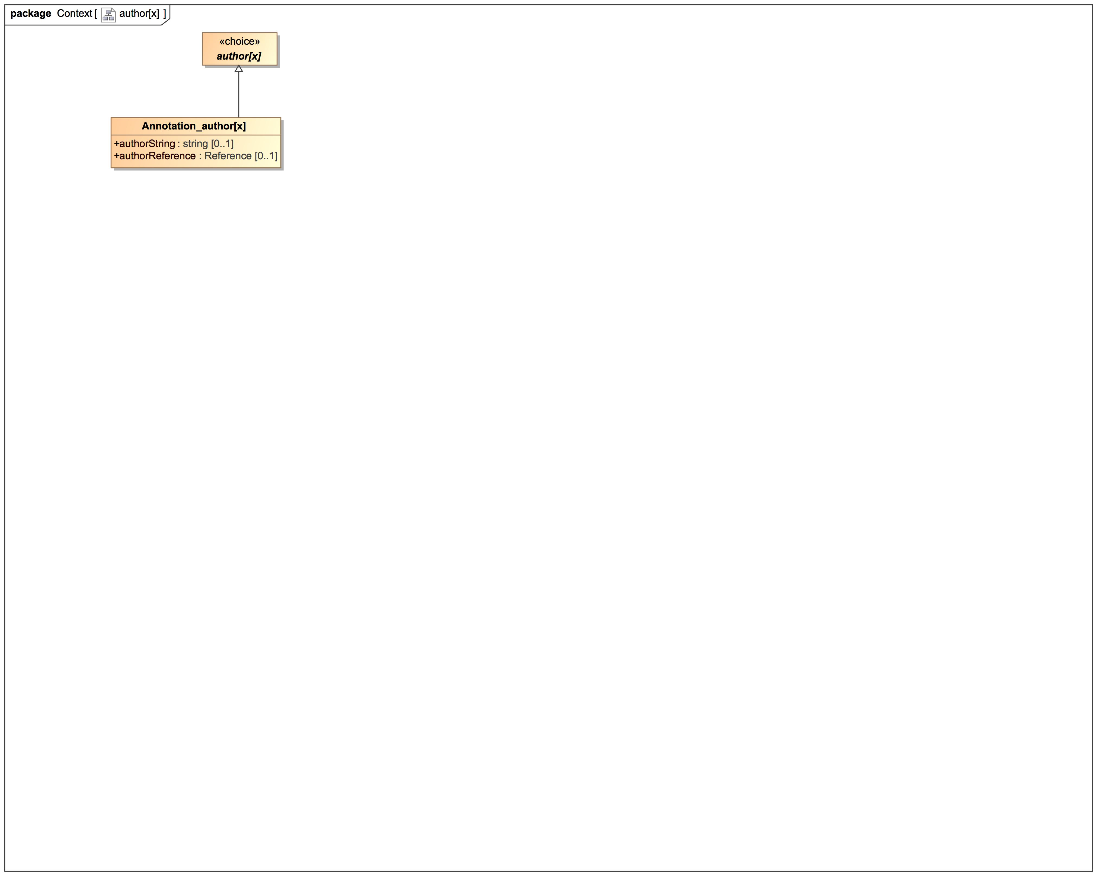

1. author[x]

### Class Annotation_author[x]

#### Direct Known Superclasses

author[x]

package FHIR::R4::Datatype

public class Annotation_author[x]

extends

author[x]

#### Attributes

 public authorString : string [0..1]

 public authorReference : Reference [0..1]

### Class author[x]

package FHIR::R4::Datatype

public abstract class author[x]

## bounds[x]

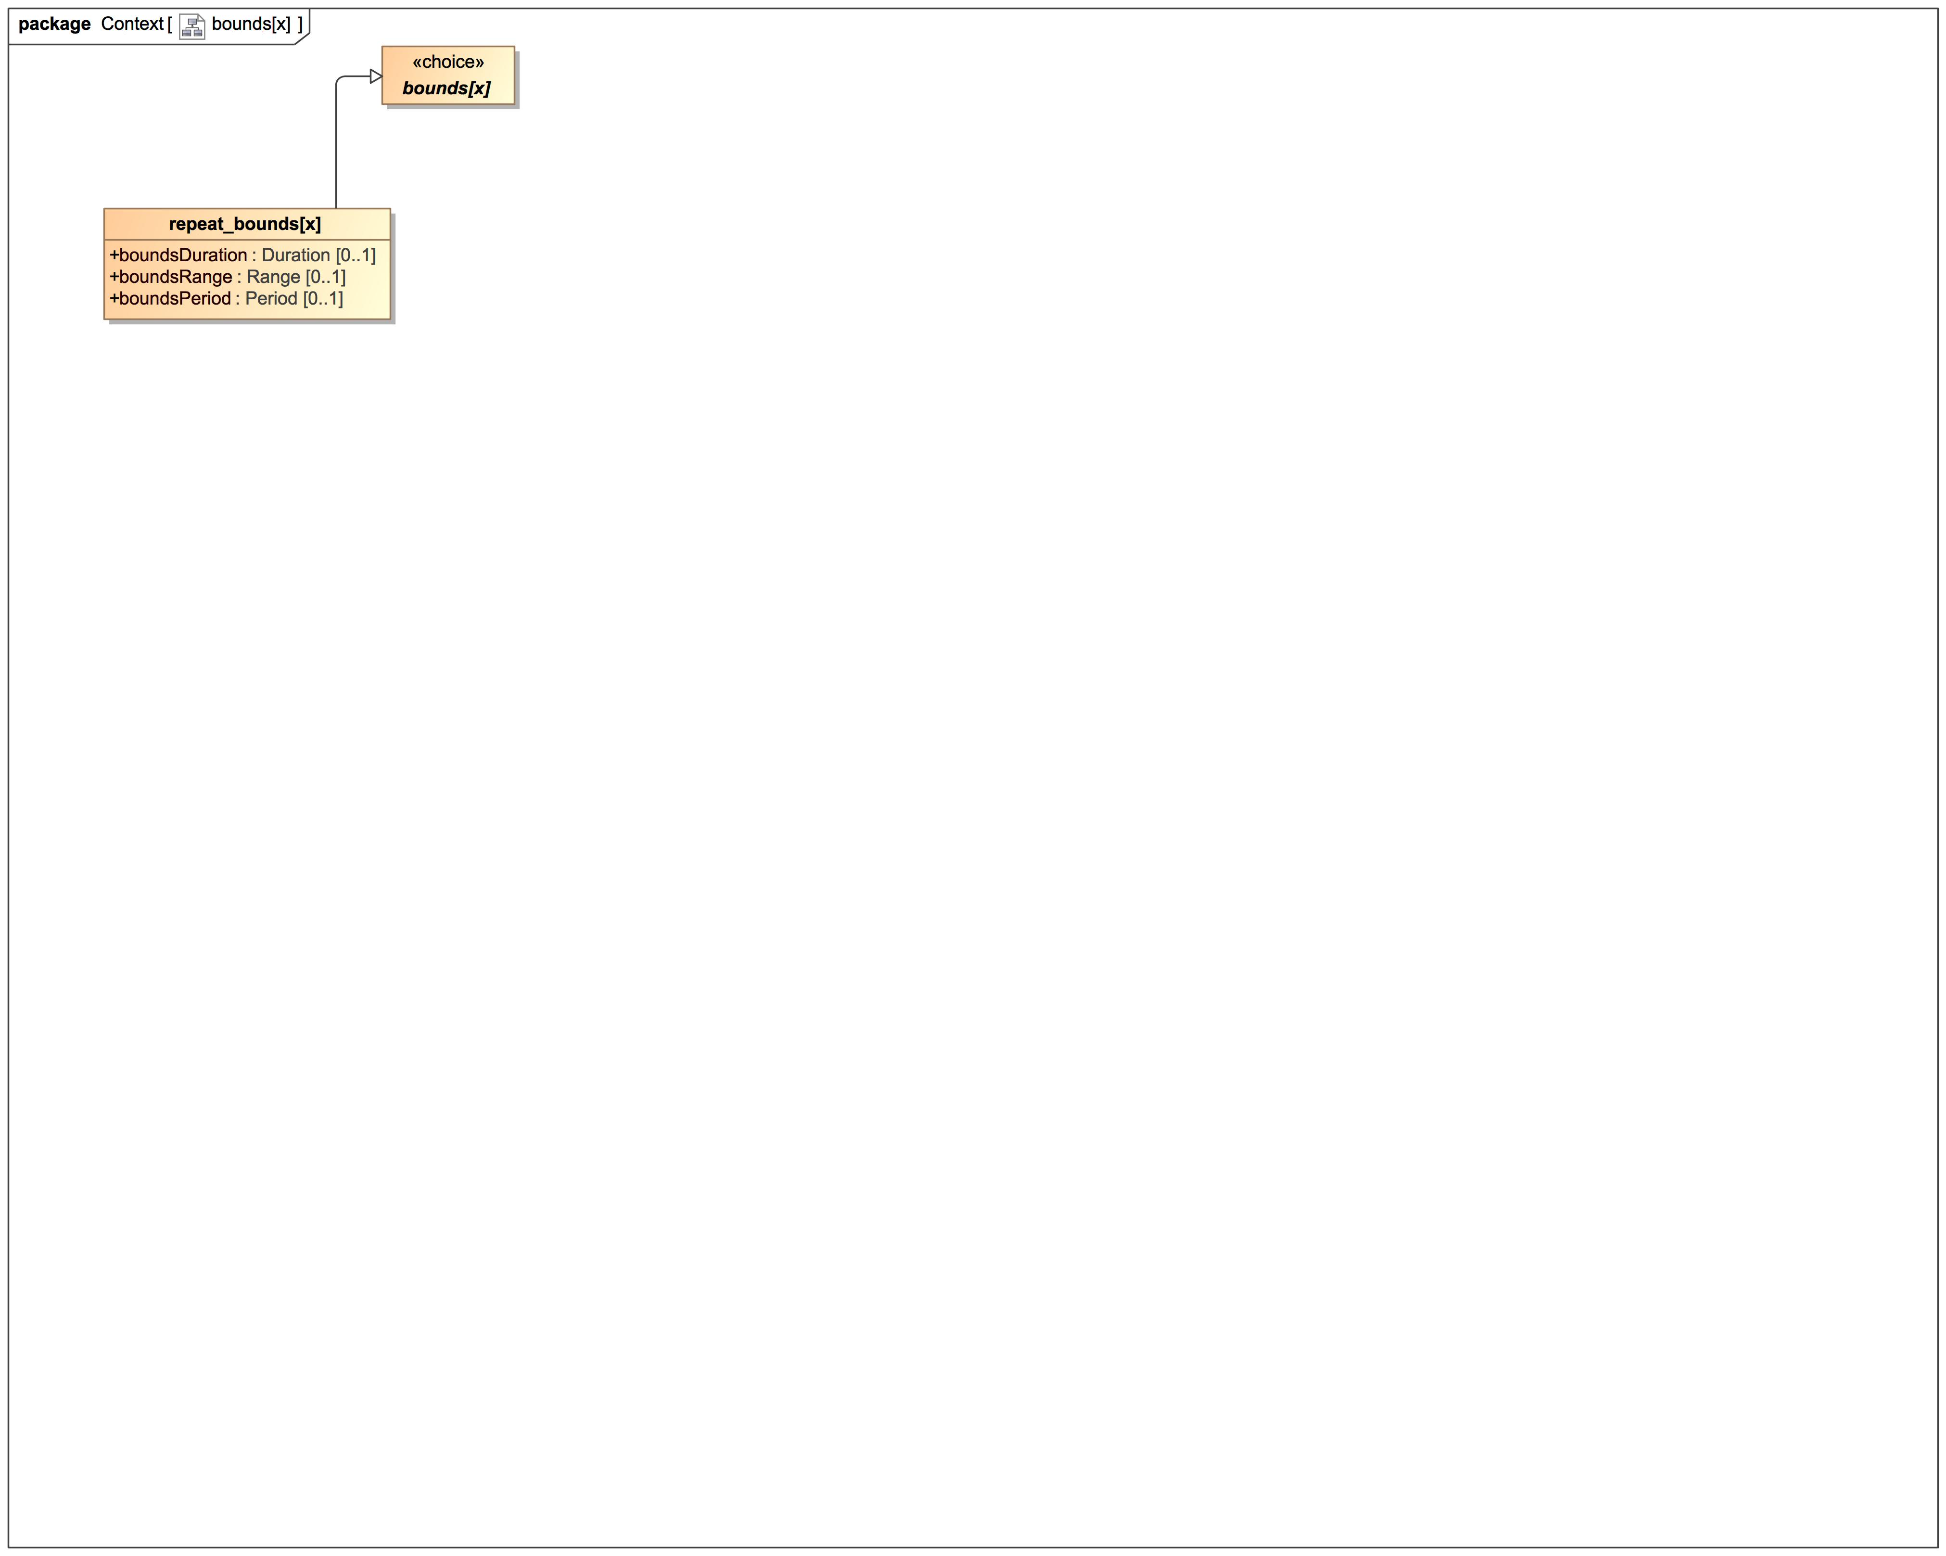

1. bounds[x]

### Class bounds[x]

package FHIR::R4::Datatype

public abstract class bounds[x]

### Class repeat_bounds[x]

#### Direct Known Superclasses

bounds[x]

package FHIR::R4::Context

public class repeat_bounds[x]

extends

bounds[x]

#### Attributes

 public boundsDuration : Duration [0..1]

 public boundsRange : Range [0..1]

 public boundsPeriod : Period [0..1]

## effective[x]

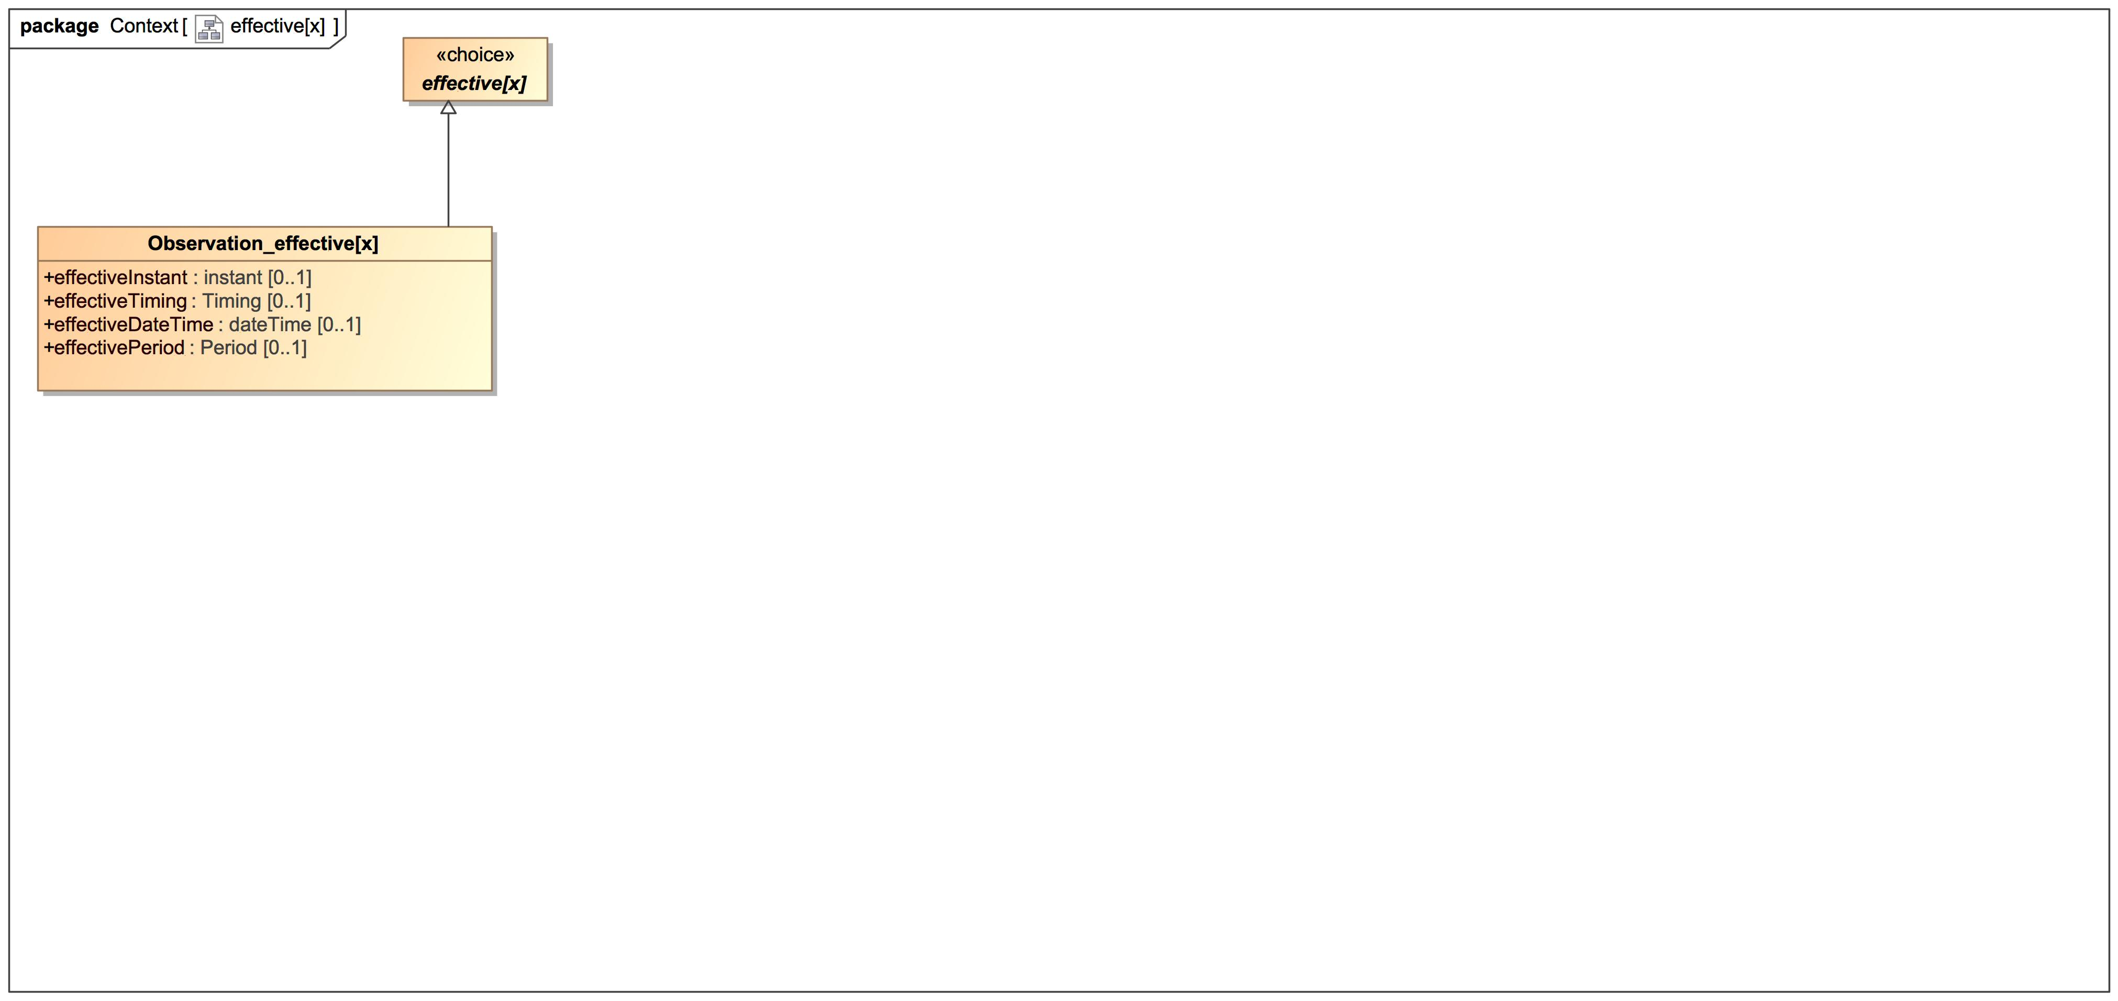

1. effective[x]

### Class effective[x]

package FHIR::R4::Datatype

public abstract class effective[x]

### Class Observation_effective[x]

#### Direct Known Superclasses

effective[x]

package FHIR::R4::Context

public class Observation_effective[x]

extends

effective[x]

#### Attributes

 public effectiveInstant : instant [0..1]

 public effectiveTiming : Timing [0..1]

 public effectiveDateTime : dateTime [0..1]

 public effectivePeriod : Period [0..1]

## value[x]

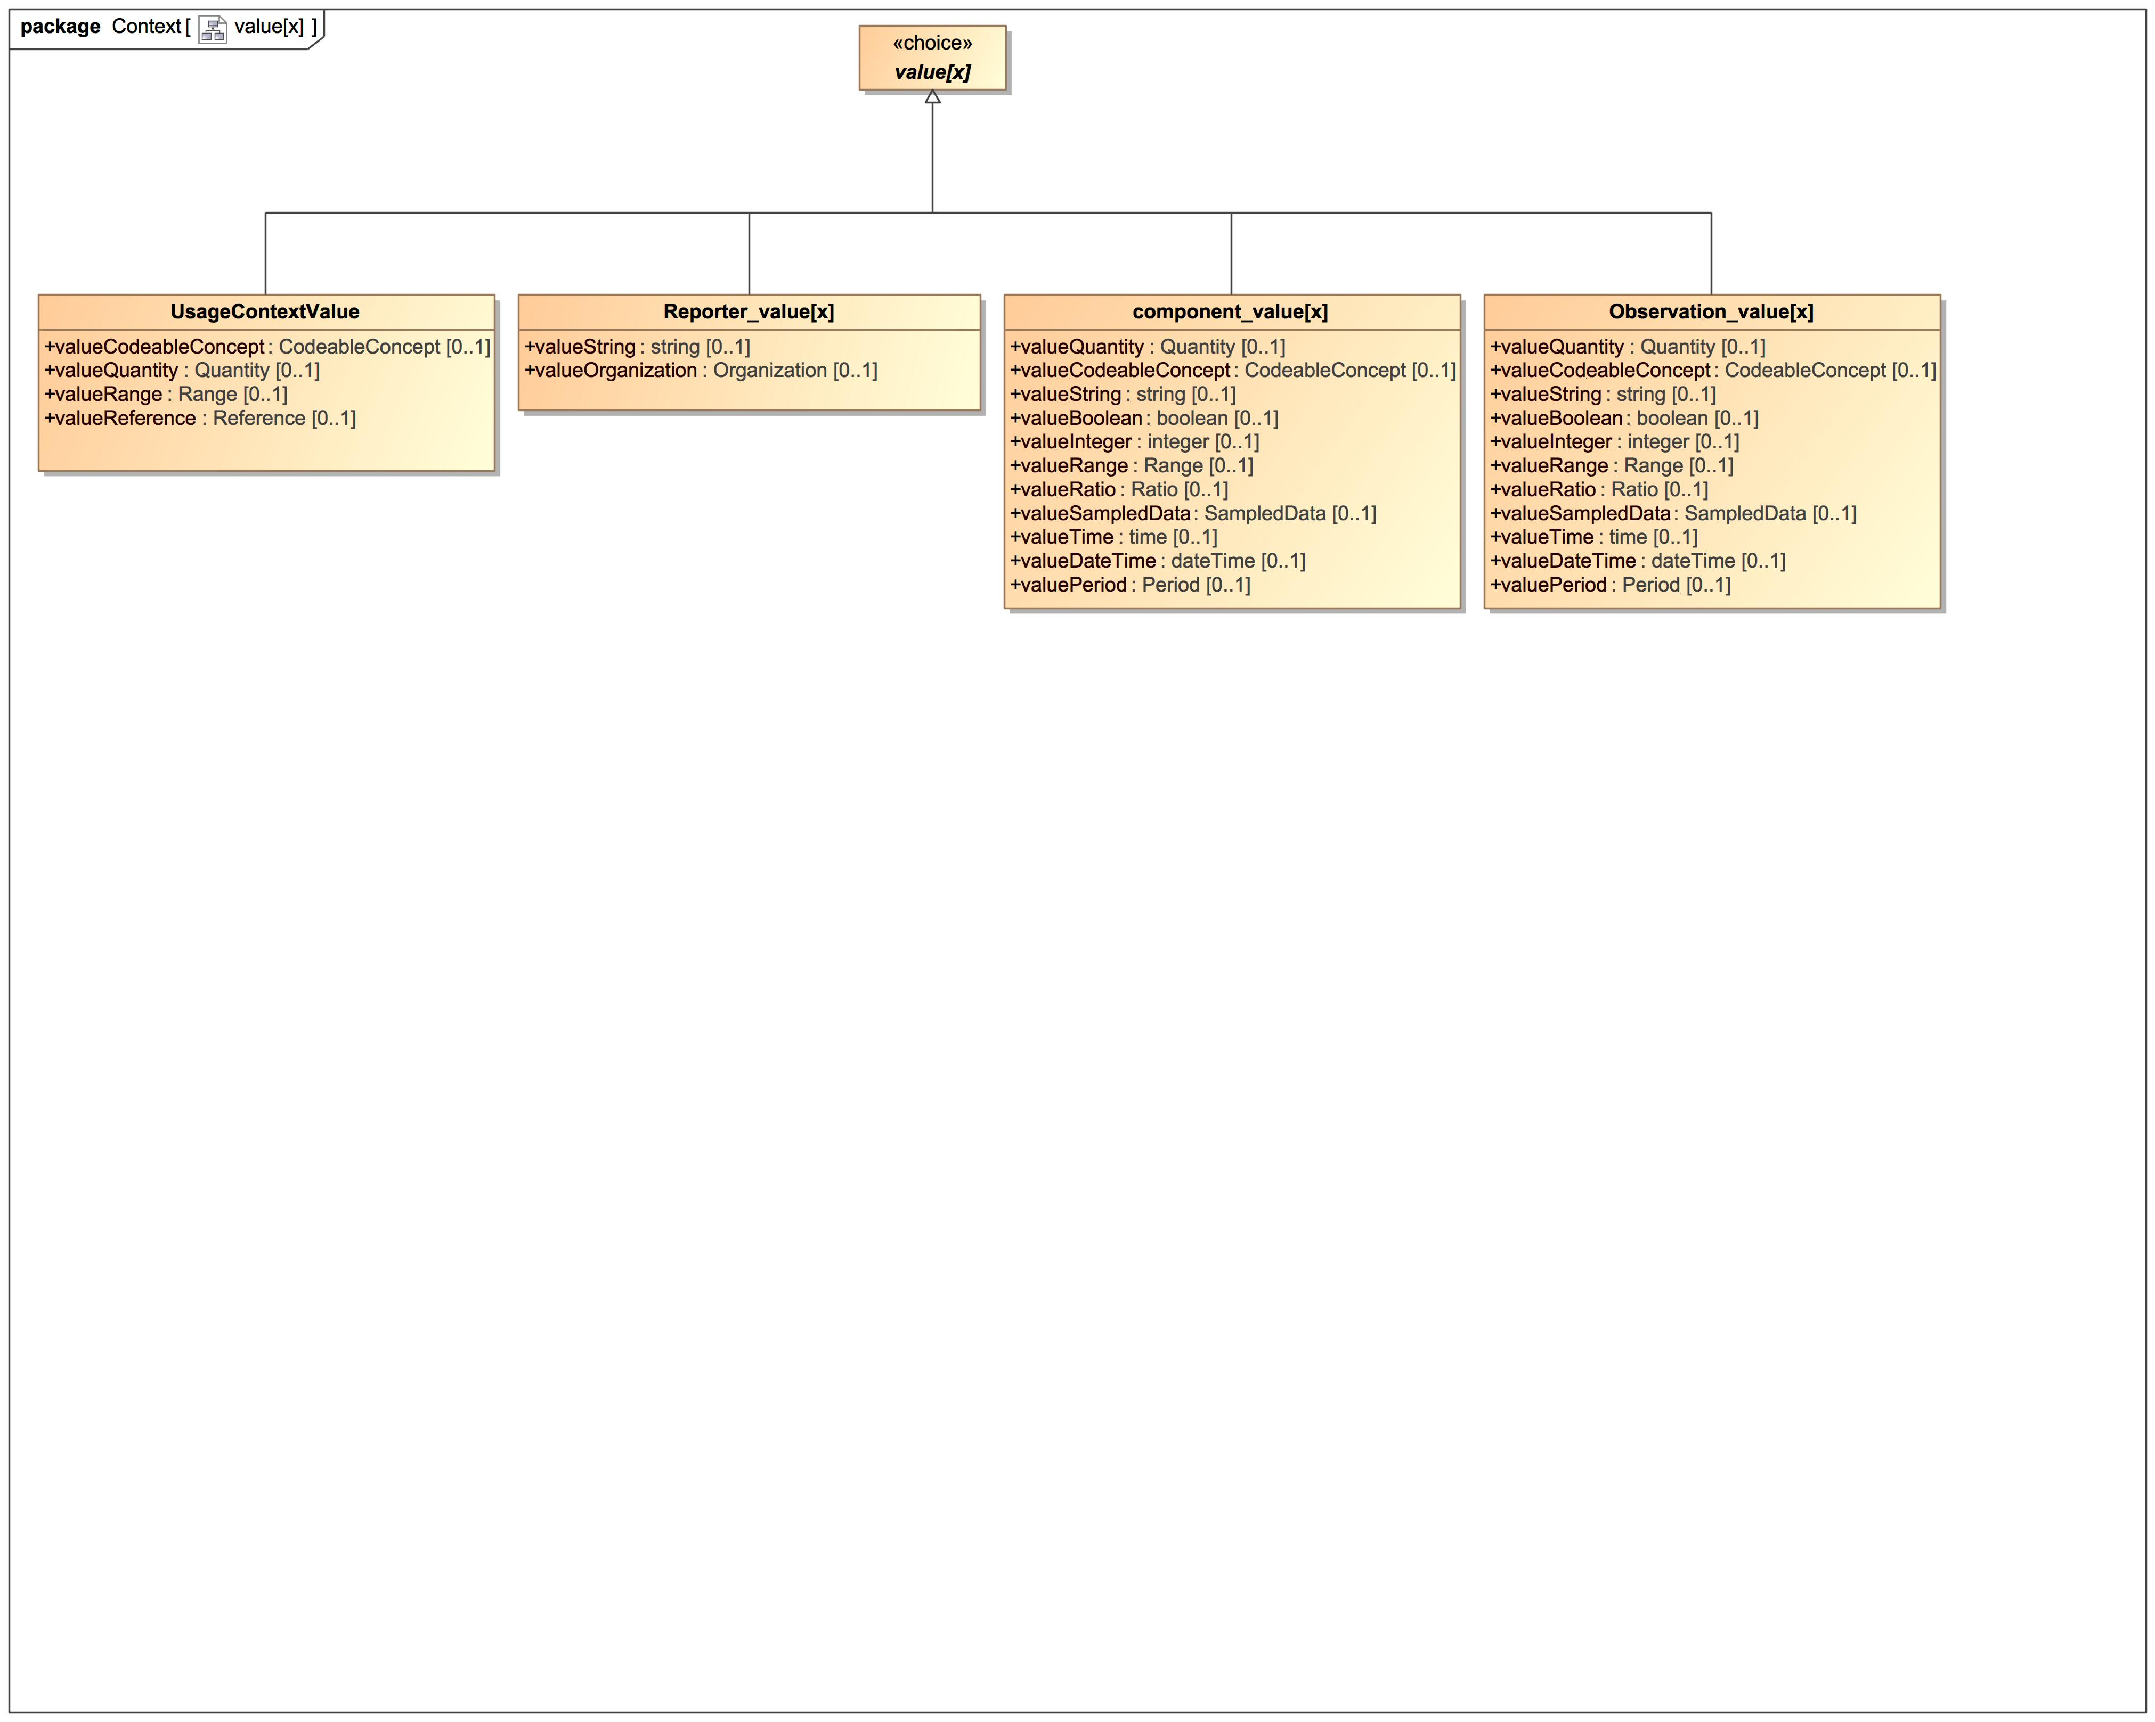

1. value[x]

### Class component_value[x]

#### Direct Known Superclasses

value[x]

package FHIR::R4::Context

public class component_value[x]

extends

value[x]

#### Attributes

 public valueQuantity : Quantity [0..1]

 public valueCodeableConcept : CodeableConcept [0..1]

 public valueString : string [0..1]

 public valueBoolean : boolean [0..1]

 public valueInteger : integer [0..1]

 public valueRange : Range [0..1]

 public valueRatio : Ratio [0..1]

 public valueSampledData : SampledData [0..1]

 public valueTime : time [0..1]

 public valueDateTime : dateTime [0..1]

 public valuePeriod : Period [0..1]

### Class Observation_value[x]

#### Direct Known Superclasses

value[x]

package FHIR::R4::Context

public class Observation_value[x]

extends

value[x]

#### Attributes

 public valueQuantity : Quantity [0..1]

 public valueCodeableConcept : CodeableConcept [0..1]

 public valueString : string [0..1]

 public valueBoolean : boolean [0..1]

 public valueInteger : integer [0..1]

 public valueRange : Range [0..1]

 public valueRatio : Ratio [0..1]

 public valueSampledData : SampledData [0..1]

 public valueTime : time [0..1]

 public valueDateTime : dateTime [0..1]

 public valuePeriod : Period [0..1]

### Class Reporter_value[x]

#### Direct Known Superclasses

value[x]

package FHIR::R4::Context

public class Reporter_value[x]

extends

value[x]

#### Attributes

 public valueString : string [0..1]

 public valueOrganization : Organization [0..1]

### Class UsageContextValue

#### Direct Known Superclasses

value[x]

package FHIR::R4::Context

public class UsageContextValue

extends

value[x]

#### Attributes

 public valueCodeableConcept : CodeableConcept [0..1]

 public valueQuantity : Quantity [0..1]

 public valueRange : Range [0..1]

 public valueReference : Reference [0..1]

### Class value[x]

package FHIR::R4::Datatype

public abstract class value[x]

# FHIR::R4::Datatype

## Datatype

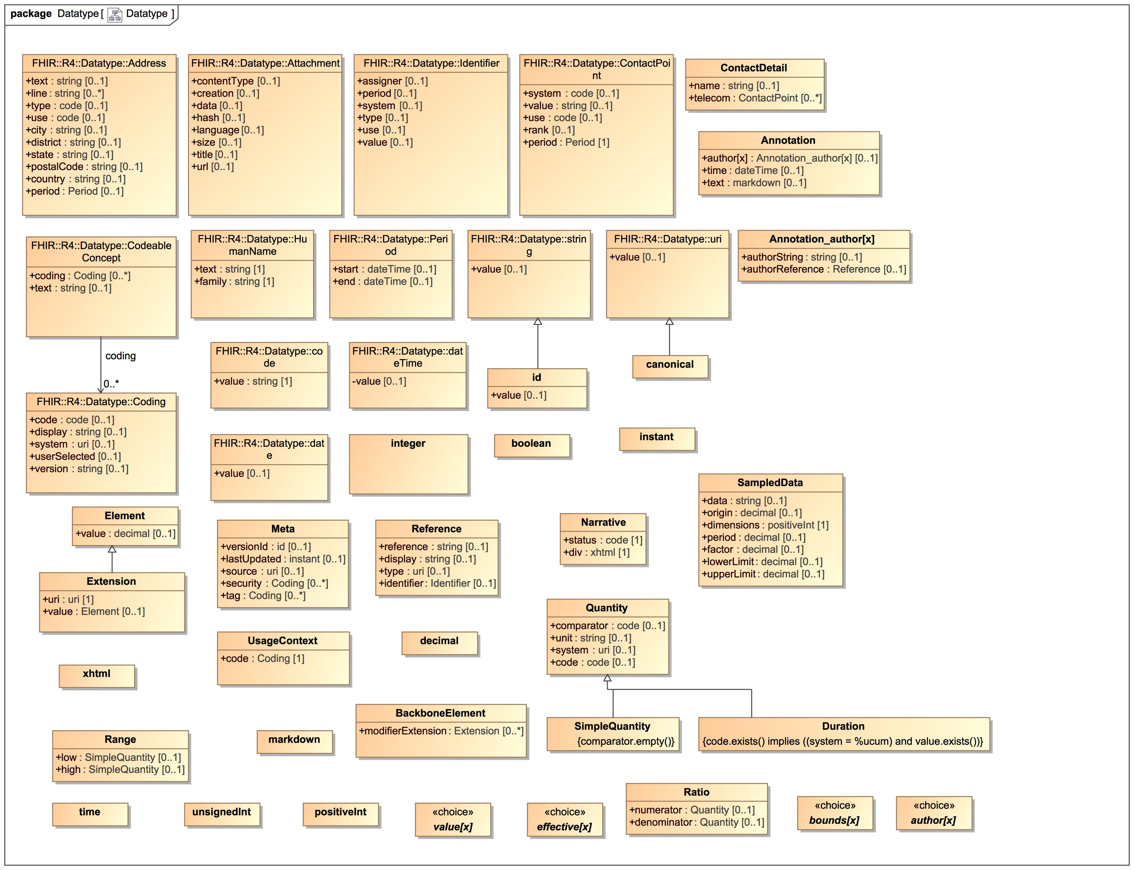

1. Datatype

### Class Address

An address expressed using postal conventions (as opposed to GPS or other location definition formats). This data type may be used to convey addresses for use in delivering mail as well as for visiting locations which might not be valid for mail delivery. There are a variety of postal address formats defined around the world.  
[ Source: https://www.hl7.org/fhir/datatypes.html#Address ]

#### Direct Known Superclasses

Element

package FHIR::R4::Datatype

public class Address

extends

Element

#### Attributes

 public text : string [0..1]

Text representation of the address

 public line : string [0..*]

Street name, number, direction & P.O. Box etc.  
This repeating element order: The order in which lines should appear in an address label

 public type : code [0..1]

postal | physical | both

 public use : code [0..1]

home | work | temp | old - purpose of this address

 public city : string [0..1]

Name of city, town etc.

 public district : string [0..1]

District name (aka county)

 public state : string [0..1]

Sub-unit of country (abbreviations ok)

 public postalCode : string [0..1]

Postal code for area

 public country : string [0..1]

Country (e.g. can be ISO 3166 2 or 3 letter code)

 public period : Period [0..1]

Time period when address was/is in use

### Class Annotation

A text note which also contains information about who made the statement and when.

#### Direct Known Superclasses

Element

package FHIR::R4::Datatype

public class Annotation

extends

Element

#### Attributes

 public author[x] : Annotation_author[x] [0..1]

 public time : dateTime [0..1]

 public text : markdown [0..1]

### Class Attachment

Content in a format defined elsewhere.  
This type is for containing or referencing attachments - additional data content defined in other formats. The most common use of this type is to include images or reports in some report format such as PDF. However it can be used for any data that has a MIME type. [Source: https://www.hl7.org/fhir/datatypes.html#attachment]

#### Direct Known Superclasses

Element

package FHIR::R4::Datatype

public class Attachment

extends

Element

#### Attributes

 public contentType [0..1]

Mime type of the content

 public creation [0..1]

Data attachment was first created

 public data [0..1]

Data inline, base64ed

 public hash [0..1]

Hash of the data (sha-1, base64ed)

 public language [0..1]

Human language of the content (BCP-47)

 public size [0..1]

Number of bytes of content (if url is provided)

 public title [0..1]

Label to display in place of the data

 public url [0..1]

uri where the data can be found

### Class BackboneElement

#### Direct Known Superclasses

Element

package FHIR::R4::Datatype

public class BackboneElement

extends

Element

#### Attributes

 public modifierExtension : Extension [0..*]

### Class boolean

true | false

#### Direct Known Superclasses

Element

package FHIR::R4::Datatype

public class boolean

extends

Element

### Class canonical

A URI that refers to a resource by its canonical URL (resources with a url property). The canonical type differs from a uri in that it has special meaning in this specification, and in that it may have a version appended, separated by a vertical bar (|). Note that the type canonical is not used for the actual canonical URLs that are the target of these references, but for the URIs that refer to them, and may have the version suffix in them. Like other URIs, elements of type canonical may also have #fragment references.

#### Direct Known Superclasses

uri

package FHIR::R4::Datatype

public class canonical

extends

uri

### Class code

Indicates that the value is taken from a set of controlled strings defined elsewhere (see Using codes for further discussion). Technically, a code is restricted to a string which has at least one character and no leading or trailing whitespace, and where there is no whitespace other than single spaces in the contents [Source: https://www.hl7.org/fhir/datatypes.html#code]

#### Direct Known Superclasses

Element

package FHIR::R4::Datatype

public class code

extends

Element

#### Attributes

 public value : string [1]

String representation of the code

### Class CodeableConcept

Concept - reference to a terminology or just text  
A CodeableConcept represents a value that is usually supplied by providing a reference to one or more terminologies or ontologies, but may also be defined by the provision of text. This is a common pattern in healthcare data. [Source: https://www.hl7.org/fhir/datatypes.html#codeableconcept]

#### Direct Known Superclasses

Element

package FHIR::R4::Datatype

public class CodeableConcept

extends

Element

#### Attributes

 public coding : Coding [0..*]

Code defined by a terminology system

 public text : string [0..1]

Plain text representation of the concept

#### Associations

 public : Coding [0..*]

A reference to a code defined by a terminology system.  
A Coding is a representation of a defined concept using a symbol from a defined "code system" [Source: https://www.hl7.org/fhir/datatypes.html#coding]

### Class Coding

A reference to a code defined by a terminology system.  
A Coding is a representation of a defined concept using a symbol from a defined "code system" [Source: https://www.hl7.org/fhir/datatypes.html#coding]

#### Direct Known Superclasses

Element

package FHIR::R4::Datatype

public class Coding

extends

Element

#### Attributes

 public code : code [0..1]

Symbol in syntax defined by the system

 public display : string [0..1]

Representation defined by the system

 public system : uri [0..1]

Identity of the terminology system

 public userSelected [0..1]

If this coding was chosen directly by the user

 public version : string [0..1]

Version of the system - if relevant

### Class ContactDetail

#### Direct Known Superclasses

Element

package FHIR::R4::Datatype

public class ContactDetail

extends

Element

#### Attributes

 public name : string [0..1]

 public telecom : ContactPoint [0..*]

### Class ContactPoint

Details for all kinds of technology-mediated contact points for a person or organization, including telephone, email, etc. [Source: https://www.hl7.org/fhir/datatypes.html#ContactPoint ]

#### Direct Known Superclasses

Element

package FHIR::R4::Datatype

public class ContactPoint

extends

Element

#### Attributes

 public system : code [0..1]

phone | fax | email | pager | url | sms | other

 public value : string [0..1]

The actual contact point details

 public use : code [0..1]

home | work | temp | old | mobile - purpose of this contact point

 public rank [0..1]

Specify preferred order of use (1 = highest)

 public period : Period [1]

Time period when the contact point was/is in use

### Class date

A date, or partial date (e.g. just year or year + month) as used in human communication. There is no time zone. Dates SHALL be valid dates [Source: https://www.hl7.org/fhir/datatypes.html#date]

#### Direct Known Superclasses

Element

package FHIR::R4::Datatype

public class date

extends

Element

#### Attributes

 public value [0..1]

String representation of date

### Class dateTime

A date, date-time or partial date (e.g. just year or year + month) as used in human communication. If hours and minutes are specified, a time zone SHALL be populated. Seconds must be provided due to schema type constraints but may be zero-filled and may be ignored. Dates SHALL be valid dates. The time "24:00" is not allowed. [Source: https://www.hl7.org/fhir/datatypes.html#datetime]

#### Direct Known Superclasses

Element

package FHIR::R4::Datatype

public class dateTime

extends

Element

#### Attributes

 private value [0..1]

string representation of the value

### Class decimal

Rational numbers that have a decimal representation. See below about the precision of the number

#### Direct Known Superclasses

Element

package FHIR::R4::Datatype

public class decimal

extends

Element

### Class Duration

#### Direct Known Superclasses

Quantity

package FHIR::R4::Datatype

public class Duration

extends

Quantity

### Class Element

The base definition for all elements contained inside a resource.

package FHIR::R4::Datatype

public class Element

#### Attributes

 public value : decimal [0..1]

### Class Extension

Every element in a resource or data type includes an optional "extension" child element that may be present any number of times.

#### Direct Known Superclasses

Element

package FHIR::R4::Datatype

public class Extension

extends

Element

#### Attributes

 public uri : uri [1]

 public value : Element [0..1]

### Class HumanName

A name of a human with text, parts and usage information.  
Names may be changed or repudiated. People may have different names in different contexts. Names may be divided into parts of different type that have variable significance depending on context, though the division into parts is not always significant. With personal names, the different parts may or may not be imbued with some implicit meaning; various cultures associate different importance with the name parts and the degree to which systems SHALL care about name parts around the world varies widely. [Source: https://www.hl7.org/fhir/datatypes.html#humanname]

#### Direct Known Superclasses

Element

package FHIR::R4::Datatype

public class HumanName

extends

Element

#### Attributes

 public text : string [1]

Text representation of the full name

 public family : string [1]

Family name (often called 'Surname')

### Class id

Any combination of upper- or lower-case ASCII letters ('A'..'Z', and 'a'..'z', numerals ('0'..'9'), '-' and '.', with a length limit of 64 characters. (This might be an integer, an un-prefixed OID, UUID or any other identifier pattern that meets these constraints.)

#### Direct Known Superclasses

string

package FHIR::R4::Datatype

public class id

extends

string

#### Attributes

 public value [0..1]

value

### Class Identifier

A numeric or alphanumeric string that is associated with a single object or entity within a given system. Typically, identifiers are used to connect content in resources to external content available in other frameworks or protocols. Identifiers are associated with objects, and may be changed or retired due to human or system process and errors. [Source:https://www.hl7.org/fhir/datatypes.html#identifier]

#### Direct Known Superclasses

Element

package FHIR::R4::Datatype

public class Identifier

extends

Element

#### Attributes

 public assigner [0..1]

Organization that issued id (may be just text)

 public period [0..1]

Time period when id is/was valid for use

 public system [0..1]

The namespace for the identifier use

 public type [0..1]

Description of identifier

 public use [0..1]

usual|official|temp|secondary (if known)

 public value [0..1]

The value that is unique

### Class instant

An instant in time in the format YYYY-MM-DDThh:mm:ss.sss+zz:zz (e.g. 2015-02-07T13:28:17.239+02:00 or 2017-01-01T00:00:00Z). The time SHALL specified at least to the second and SHALL include a time zone. Note: This is intended for when precisely observed times are required (typically system logs etc.), and not human-reported times - for those, use date or dateTime (which can be as precise as instant, but is not required to be). instant is a more constrained dateTime.

#### Direct Known Superclasses

Element

package FHIR::R4::Datatype

public class instant

extends

Element

### Class integer

A signed integer in the range −2,147,483,648..2,147,483,647 (32-bit; for larger values, use decimal) [Source: FHIR]

#### Direct Known Superclasses

Element

package FHIR::R4::Datatype

public class integer

extends

Element

### Class markdown

A FHIR string (see above) that may contain markdown syntax for optional processing by a markdown presentation engine, in the GFM extension of CommonMark format (see below)  
Regex: \s*(\S|\s)* (can't put size limit in the regex - too large)

#### Direct Known Superclasses

string

package FHIR::R4::Datatype

public class markdown

extends

string

### Class Meta

An address expressed using postal conventions (as opposed to GPS or other location definition formats). This data type may be used to convey addresses for use in delivering mail as well as for visiting locations which might not be valid for mail delivery. There are a variety of postal address formats defined around the world.  
[ Source: https://www.hl7.org/fhir/datatypes.html#Address ]

#### Direct Known Superclasses

Element

package FHIR::R4::Datatype

public class Meta

extends

Element

#### Attributes

 public versionId : id [0..1]

Text representation of the address

 public lastUpdated : instant [0..1]

Street name, number, direction & P.O. Box etc.  
This repeating element order: The order in which lines should appear in an address label

 public source : uri [0..1]

postal | physical | both

 public security : Coding [0..*]

home | work | temp | old - purpose of this address

 public tag : Coding [0..*]

Name of city, town etc.

### Class Narrative

#### Direct Known Superclasses

Element

package FHIR::R4::Datatype

public class Narrative

extends

Element

#### Attributes

 public status : code [1]

 public div : xhtml [1]

### Class Period

A time period defined by a start and end date/time. A period specifies a range of times. The context of use will specify whether the entire range applies (e.g. "the patient was an inpatient of the hospital for this time range") or one value from the period applies (e.g. "give to the patient between 2 and 4 pm on 24-Jun 2013"). [ Source: https://www.hl7.org/fhir/datatypes.html#Period ]

#### Direct Known Superclasses

Element

package FHIR::R4::Datatype

public class Period

extends

Element

#### Attributes

 public start : dateTime [0..1]

Starting time with inclusive boundary

 public end : dateTime [0..1]

End time with inclusive boundary, if not ongoing

### Class positiveInt

Any positive integer in the range 1..2,147,483,647  
Regex: +?[1-9][0-9]*

#### Direct Known Superclasses

Element

package FHIR::R4::Datatype

public class positiveInt

extends

Element

### Class Quantity

#### Direct Known Superclasses

Element

package FHIR::R4::Datatype

public class Quantity

extends

Element

#### Attributes

 public comparator : code [0..1]

 public unit : string [0..1]

 public system : uri [0..1]

 public code : code [0..1]

### Class Range

A set of ordered Quantity values defined by a low and high limit. A Range specifies a set of possible values; usually, one value from the range applies (e.g. "give the patient between 2 and 4 tablets"). Ranges are typically used in instructions.

package FHIR::R4::Datatype

public class Range

#### Attributes

 public low : SimpleQuantity [0..1]

 public high : SimpleQuantity [0..1]

### Class Ratio

A set of ordered Quantity values defined by a low and high limit. A Range specifies a set of possible values; usually, one value from the range applies (e.g. "give the patient between 2 and 4 tablets"). Ranges are typically used in instructions.

#### Direct Known Superclasses

Element

package FHIR::R4::Datatype

public class Ratio

extends

Element

#### Attributes

 public numerator : Quantity [0..1]

 public denominator : Quantity [0..1]

### Class Reference

A reference from one resource to another.

#### Direct Known Superclasses

Element

package FHIR::R4::Datatype

public class Reference

extends

Element

#### Attributes

 public reference : string [0..1]

 public display : string [0..1]

 public type : uri [0..1]

 public identifier : Identifier [0..1]

### Class SampledData

A reference from one resource to another.

#### Direct Known Superclasses

Element

package FHIR::R4::Datatype

public class SampledData

extends

Element

#### Attributes

 public data : string [0..1]

 public origin : decimal [0..1]

 public dimensions : positiveInt [1]

 public period : decimal [0..1]

 public factor : decimal [0..1]

 public lowerLimit : decimal [0..1]

 public upperLimit : decimal [0..1]

### Class SimpleQuantity

#### Direct Known Superclasses

Quantity

package FHIR::R4::Datatype

public class SimpleQuantity

extends

Quantity

### Class string

A sequence of Unicode characters. Note that strings SHALL NOT exceed 1MB in size. String should not contain Unicode character points below 32, except for u0009 (horizontal tab), u0010 (carriage return) and u0013 (line feed) [Source: https://www.hl7.org/fhir/datatypes.html#string]

#### Direct Known Superclasses

Element

package FHIR::R4::Datatype

public class string

extends

Element

#### Attributes

 public value [0..1]

value

### Class time

A time during the day, in the format hh:mm:ss. There is no date specified. Seconds must be provided due to schema type constraints but may be zero-filled and may be ignored at receiver discretion. The time "24:00" SHALL NOT be used. A time zone SHALL NOT be present. Times can be converted to a Duration since midnight.  
Regex: ([01][0-9]|2[0-3]):[0-5][0-9]:([0-5][0-9]|60)(\.[0-9]+)?

#### Direct Known Superclasses

Element

package FHIR::R4::Datatype

public class time

extends

Element

### Class unsignedInt

Any non-negative integer in the range 0..2,147,483,647  
Regex: [0]|([1-9][0-9]*)

#### Direct Known Superclasses

Element

package FHIR::R4::Datatype

public class unsignedInt

extends

Element

### Class uri

A Uniform Resource Identifier Reference (RFC 3986 ). Note: URIs are case sensitive. For UUID (urn:uuid:53fefa32-fcbb-4ff8-8a92-55ee120877b7) use all lowercase. URIs can be absolute or relative, and may have an optional fragment identifier. [Source: https://www.hl7.org/fhir/datatypes.html#uri]

#### Direct Known Superclasses

Element

package FHIR::R4::Datatype

public class uri

extends

Element

#### Attributes

 public value [0..1]

String representation of the uri

### Class UsageContext

#### Direct Known Superclasses

Element

package FHIR::R4::Datatype

public class UsageContext

extends

Element

#### Attributes

 public code : Coding [1]

### Class xhtml

#### Direct Known Superclasses

Element

package FHIR::R4::Datatype

public class xhtml

extends

Element

### Known other classes

Class Annotation_author[x], Class author[x], Class bounds[x], Class effective[x], Class value[x]

# FHIR::R4::Extension

## Extension

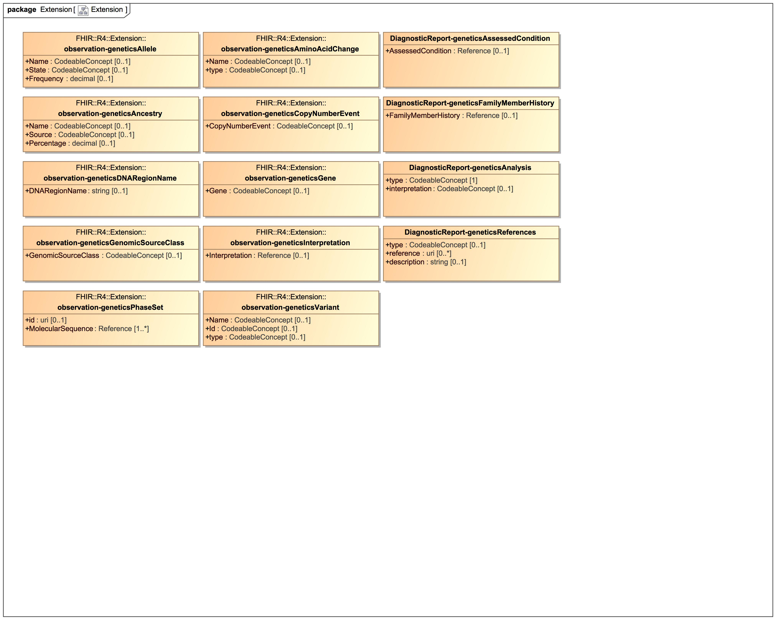

1. Extension

### Class DiagnosticReport-geneticsAnalysis

#### Direct Known Superclasses

DiagnosticReport

package FHIR::R4::Extension

public class DiagnosticReport-geneticsAnalysis

extends

DiagnosticReport

#### Attributes

 public type : CodeableConcept [1]

 public interpretation : CodeableConcept [0..1]

### Class DiagnosticReport-geneticsAssessedCondition

#### Direct Known Superclasses

DiagnosticReport

package FHIR::R4::Extension

public class DiagnosticReport-geneticsAssessedCondition

extends

DiagnosticReport

#### Attributes

 public AssessedCondition : Reference [0..1]

### Class DiagnosticReport-geneticsFamilyMemberHistory

#### Direct Known Superclasses

DiagnosticReport

package FHIR::R4::Extension

public class DiagnosticReport-geneticsFamilyMemberHistory

extends

DiagnosticReport

#### Attributes

 public FamilyMemberHistory : Reference [0..1]

### Class DiagnosticReport-geneticsReferences

#### Direct Known Superclasses

DiagnosticReport

package FHIR::R4::Extension

public class DiagnosticReport-geneticsReferences

extends

DiagnosticReport

#### Attributes

 public type : CodeableConcept [0..1]

 public reference : uri [0..*]

 public description : string [0..1]

### Class observation-geneticsAllele

#### Direct Known Superclasses

Observation

package FHIR::R4::Extension

public class observation-geneticsAllele

extends

Observation

#### Attributes

 public Name : CodeableConcept [0..1]

 public State : CodeableConcept [0..1]

 public Frequency : decimal [0..1]

### Class observation-geneticsAminoAcidChange

#### Direct Known Superclasses

Observation

package FHIR::R4::Extension

public class observation-geneticsAminoAcidChange

extends

Observation

#### Attributes

 public Name : CodeableConcept [0..1]

 public type : CodeableConcept [0..1]

### Class observation-geneticsAncestry

#### Direct Known Superclasses

Observation

package FHIR::R4::Extension

public class observation-geneticsAncestry

extends

Observation

#### Attributes

 public Name : CodeableConcept [0..1]

 public Source : CodeableConcept [0..1]

 public Percentage : decimal [0..1]

### Class observation-geneticsCopyNumberEvent

#### Direct Known Superclasses

Observation

package FHIR::R4::Extension

public class observation-geneticsCopyNumberEvent

extends

Observation

#### Attributes

 public CopyNumberEvent : CodeableConcept [0..1]

### Class observation-geneticsDNARegionName

#### Direct Known Superclasses

Observation

package FHIR::R4::Extension

public class observation-geneticsDNARegionName

extends

Observation

#### Attributes

 public DNARegionName : string [0..1]

### Class observation-geneticsGene

#### Direct Known Superclasses

Observation

package FHIR::R4::Extension

public class observation-geneticsGene

extends

Observation

#### Attributes

 public Gene : CodeableConcept [0..1]

### Class observation-geneticsGenomicSourceClass

#### Direct Known Superclasses

Observation

package FHIR::R4::Extension

public class observation-geneticsGenomicSourceClass

extends

Observation

#### Attributes

 public GenomicSourceClass : CodeableConcept [0..1]

### Class observation-geneticsInterpretation

#### Direct Known Superclasses

Observation

package FHIR::R4::Extension

public class observation-geneticsInterpretation

extends

Observation

#### Attributes

 public Interpretation : Reference [0..1]

### Class observation-geneticsPhaseSet

#### Direct Known Superclasses

Observation

package FHIR::R4::Extension

public class observation-geneticsPhaseSet

extends

Observation

#### Attributes

 public id : uri [0..1]

 public MolecularSequence : Reference [1..*]

### Class observation-geneticsVariant

#### Direct Known Superclasses

Observation

package FHIR::R4::Extension

public class observation-geneticsVariant

extends

Observation

#### Attributes

 public Name : CodeableConcept [0..1]

 public Id : CodeableConcept [0..1]

 public type : CodeableConcept [0..1]

# FHIR::R4::Profile

### Class DiagnosticReport-genetics

Describes how the observation resource is used to report structured genetic test results.

#### Direct Known Superclasses

Observation

package FHIR::R4::Profile

public class DiagnosticReport-genetics

extends

Observation

#### Attributes

 public diagnosticReport-geneticsAssessedCondition : DiagnosticReport-geneticsAssessedCondition [0..*]

 public diagnosticReport-geneticsFamilyMemberHistory : DiagnosticReport-geneticsFamilyMemberHistory [0..*]

 public diagnosticReport-geneticsAnalysis : DiagnosticReport-geneticsAnalysis [0..*]

 public diagnosticReport-geneticsReferences : DiagnosticReport-geneticsReferences [0..*]

### Class Observation-genetics

Describes how the observation resource is used to report structured genetic test results.

#### Direct Known Superclasses

Observation

package FHIR::R4::Profile

public class Observation-genetics

extends

Observation

#### Attributes

 public observation-geneticsGene : CodeableConcept [0..1]

 public observation-geneticsDNARegionName : string [0..1]

 public observation-geneticsCopyNumberEvent : CodeableConcept [0..1]

 public observation-geneticsGenomicSourceClass : CodeableConcept [0..1]

 public observation-geneticsInterpretation : Reference [0..1]

 public observation-geneticsVariant : observation-geneticsVariant [0..1]

 public observation-geneticsAminoAcidChange : observation-geneticsAminoAcidChange [0..1]

 public observation-geneticsAllele : observation-geneticsAllele [0..1]

 public observation-geneticsAncestry : observation-geneticsAncestry [0..1]

 public observation-geneticsPhaseSet : observation-geneticsPhaseSet [0..*]

# FHIR::R4::Resource

## Auxiliary

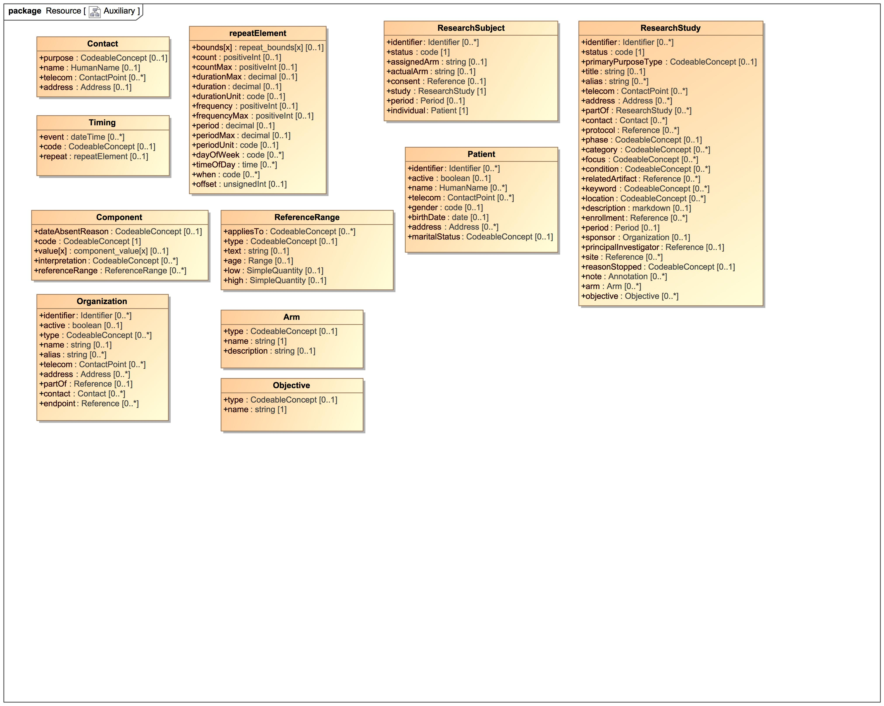

1. Auxiliary

### Class Arm

A timing schedule that specifies an event that may occur multiple times

#### Direct Known Superclasses

BackboneElement

package FHIR::R4::Resource

public class Arm

extends

BackboneElement

#### Attributes

 public type : CodeableConcept [0..1]

 public name : string [1]

 public description : string [0..1]

### Class Component

A timing schedule that specifies an event that may occur multiple times

#### Direct Known Superclasses

BackboneElement

package FHIR::R4::Resource

public class Component

extends

BackboneElement

#### Attributes

 public dateAbsentReason : CodeableConcept [0..1]

 public code : CodeableConcept [1]

 public value[x] : component_value[x] [0..1]

 public interpretation : CodeableConcept [0..*]

 public referenceRange : ReferenceRange [0..*]

### Class Contact

Contact with a certain purpose

#### Direct Known Superclasses

BackboneElement

package FHIR::R4::Resource

public class Contact

extends

BackboneElement

#### Attributes

 public purpose : CodeableConcept [0..1]

 public name : HumanName [0..1]

 public telecom : ContactPoint [0..*]

 public address : Address [0..1]

### Class Objective

A timing schedule that specifies an event that may occur multiple times

#### Direct Known Superclasses

BackboneElement

package FHIR::R4::Resource

public class Objective

extends

BackboneElement

#### Attributes

 public type : CodeableConcept [0..1]

 public name : string [1]

### Class Organization

#### Direct Known Superclasses

DomainResource

package FHIR::R4::Resource

public class Organization

extends

DomainResource

#### Attributes

 public identifier : Identifier [0..*]

 public active : boolean [0..1]

 public type : CodeableConcept [0..*]

 public name : string [0..1]

 public alias : string [0..*]

 public telecom : ContactPoint [0..*]

 public address : Address [0..*]

 public partOf : Reference [0..1]

 public contact : Contact [0..*]

 public endpoint : Reference [0..*]

### Class Patient

#### Direct Known Superclasses

DomainResource

package FHIR::R4::Resource

public class Patient

extends

DomainResource

#### Attributes

 public identifier : Identifier [0..*]

 public active : boolean [0..1]

 public name : HumanName [0..*]

 public telecom : ContactPoint [0..*]

 public gender : code [0..1]

 public birthDate : date [0..1]

 public address : Address [0..*]

 public maritalStatus : CodeableConcept [0..1]

### Class ReferenceRange

A timing schedule that specifies an event that may occur multiple times

#### Direct Known Superclasses

BackboneElement

package FHIR::R4::Resource

public class ReferenceRange

extends

BackboneElement

#### Attributes

 public appliesTo : CodeableConcept [0..*]

 public type : CodeableConcept [0..1]

 public text : string [0..1]

 public age : Range [0..1]

 public low : SimpleQuantity [0..1]

 public high : SimpleQuantity [0..1]

### Class repeatElement

#### Direct Known Superclasses

Element

package FHIR::R4::Resource

public class repeatElement

extends

Element

#### Attributes

 public bounds[x] : repeat_bounds[x] [0..1]

 public count : positiveInt [0..1]

 public countMax : positiveInt [0..1]

 public durationMax : decimal [0..1]

 public duration : decimal [0..1]

 public durationUnit : code [0..1]

 public frequency : positiveInt [0..1]

 public frequencyMax : positiveInt [0..1]

 public period : decimal [0..1]

 public periodMax : decimal [0..1]

 public periodUnit : code [0..1]

 public dayOfWeek : code [0..*]

 public timeOfDay : time [0..*]

 public when : code [0..*]

 public offset : unsignedInt [0..1]

### Class ResearchStudy

#### Direct Known Superclasses

DomainResource

package FHIR::R4::Resource

public class ResearchStudy

extends

DomainResource

#### Attributes

 public identifier : Identifier [0..*]

 public status : code [1]

 public primaryPurposeType : CodeableConcept [0..1]

 public title : string [0..1]

 public alias : string [0..*]

 public telecom : ContactPoint [0..*]

 public address : Address [0..*]

 public partOf : ResearchStudy [0..*]

 public contact : Contact [0..*]

 public protocol : Reference [0..*]

 public phase : CodeableConcept [0..1]

 public category : CodeableConcept [0..*]

 public focus : CodeableConcept [0..*]

 public condition : CodeableConcept [0..*]

 public relatedArtifact : Reference [0..*]

 public keyword : CodeableConcept [0..*]

 public location : CodeableConcept [0..*]

 public description : markdown [0..1]

 public enrollment : Reference [0..*]

 public period : Period [0..1]

 public sponsor : Organization [0..1]

 public principalInvestigator : Reference [0..1]

 public site : Reference [0..*]

 public reasonStopped : CodeableConcept [0..1]

 public note : Annotation [0..*]

 public arm : Arm [0..*]

 public objective : Objective [0..*]

### Class ResearchSubject

#### Direct Known Superclasses

DomainResource

package FHIR::R4::Resource

public class ResearchSubject

extends

DomainResource

#### Attributes

 public identifier : Identifier [0..*]

 public status : code [1]

 public assignedArm : string [0..1]

 public actualArm : string [0..1]

 public consent : Reference [0..1]

 public study : ResearchStudy [1]

 public period : Period [0..1]

 public individual : Patient [1]

### Class Timing

A timing schedule that specifies an event that may occur multiple times

#### Direct Known Superclasses

BackboneElement

package FHIR::R4::Resource

public class Timing

extends

BackboneElement

#### Attributes

 public event : dateTime [0..*]

 public code : CodeableConcept [0..1]

 public repeat : repeatElement [0..1]

## basic

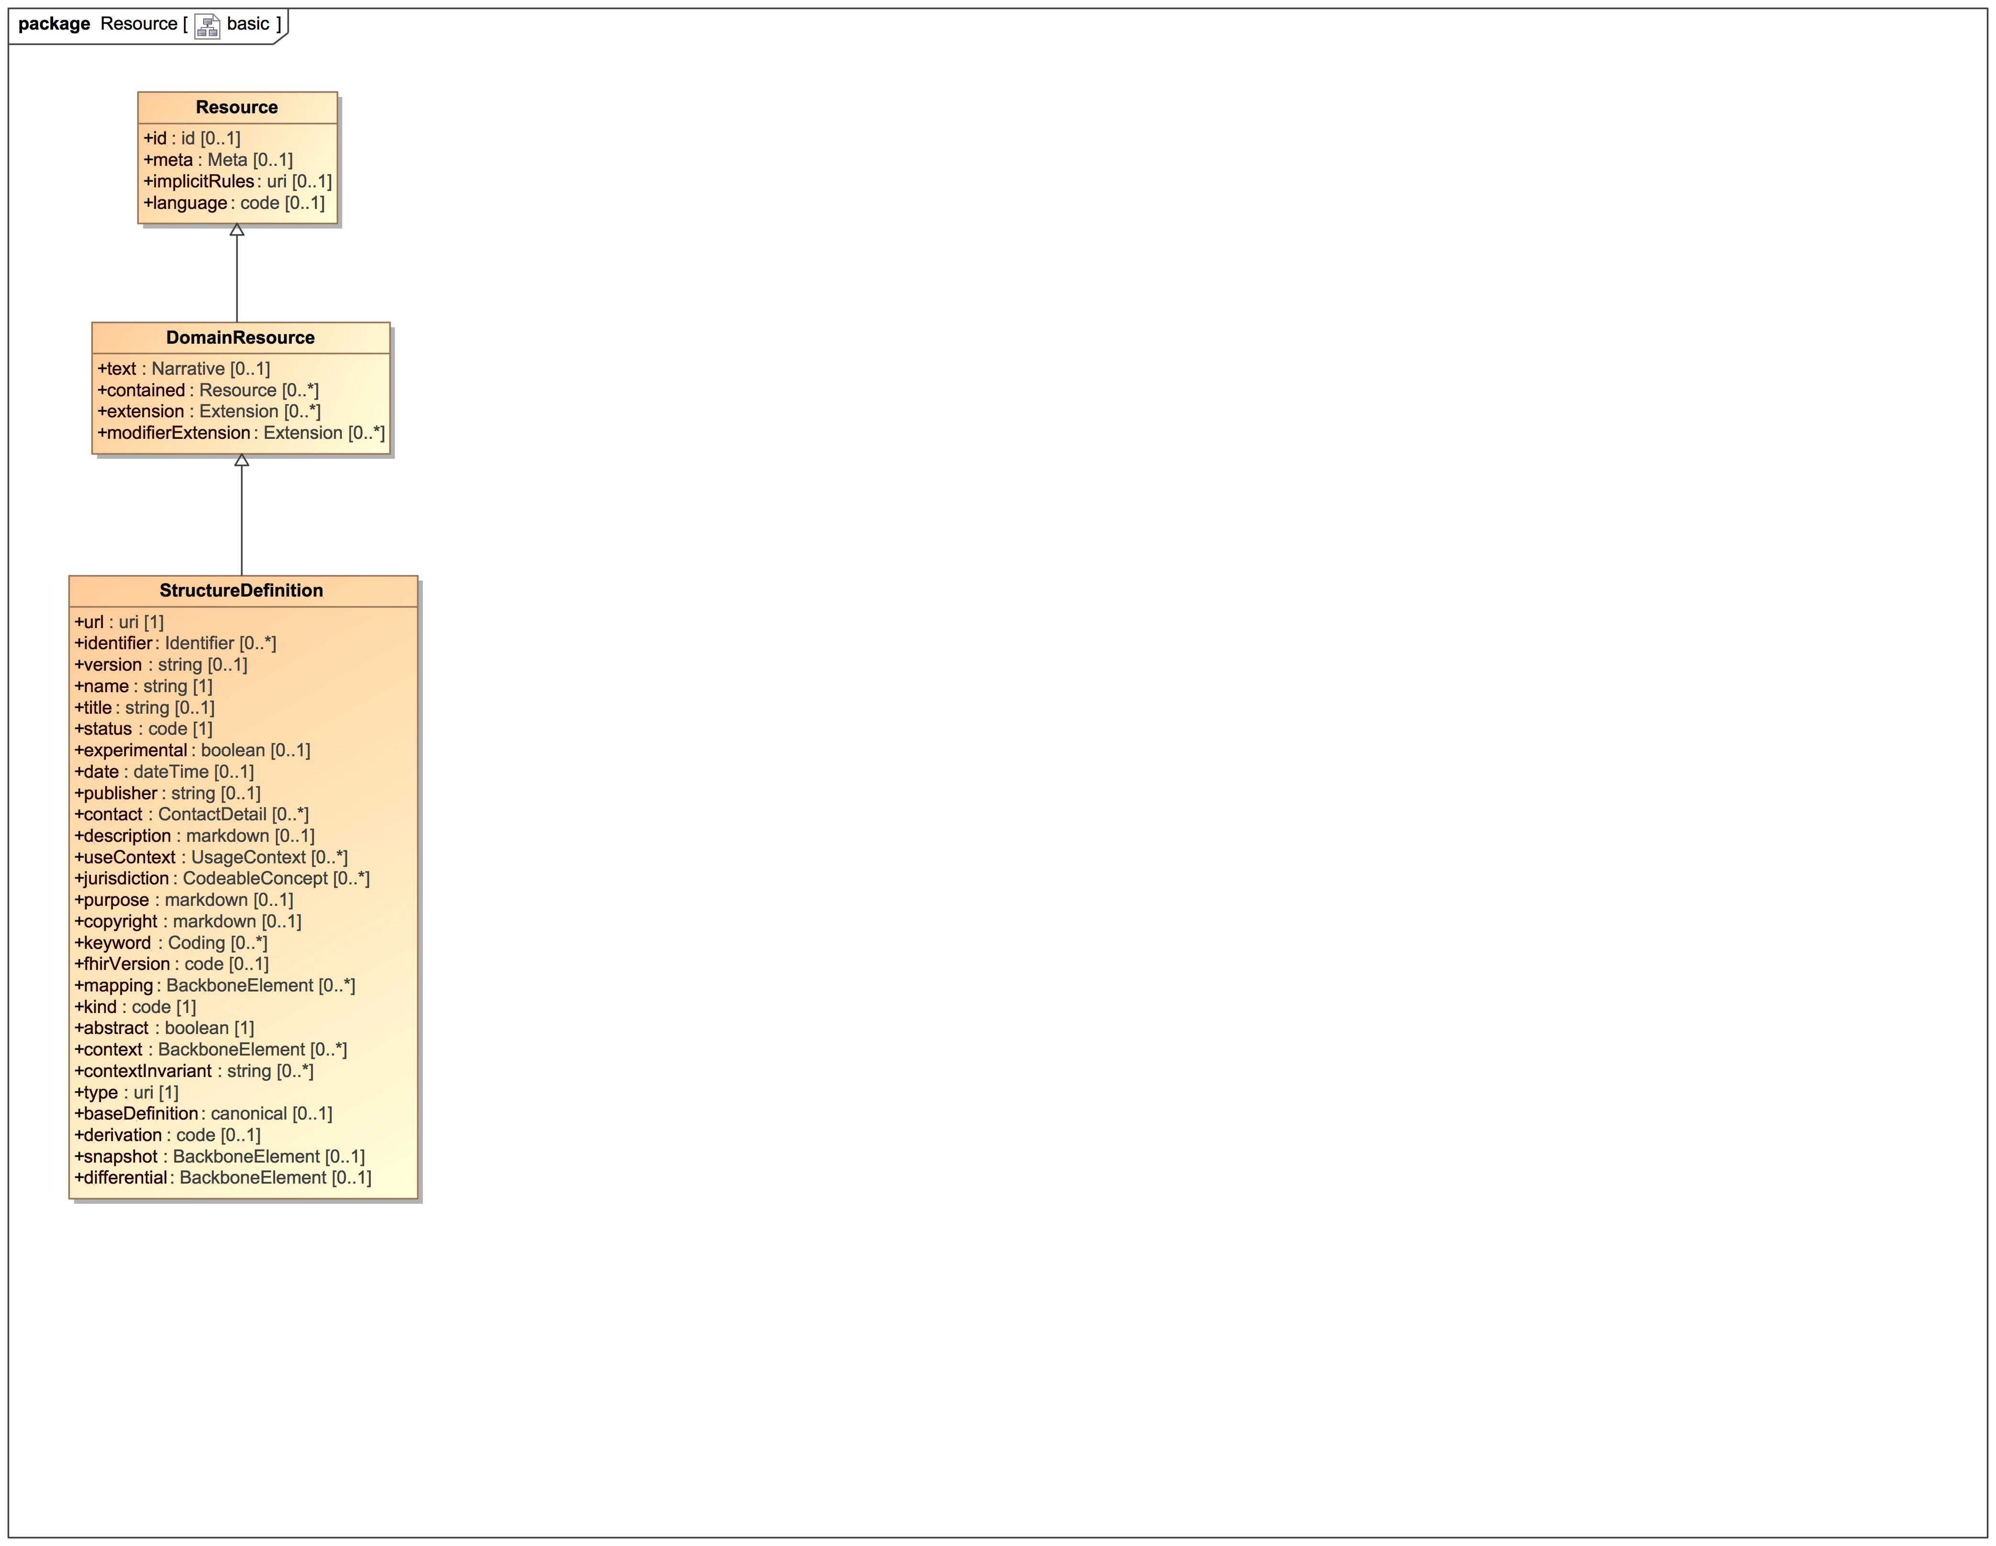

1. basic

### Class DomainResource

A resource with narrative, extensions, and contained resources

#### Direct Known Superclasses

Resource

package FHIR::R4::Resource

public class DomainResource

extends

Resource

#### Attributes

 public text : Narrative [0..1]

 public contained : Resource [0..*]

 public extension : Extension [0..*]

 public modifierExtension : Extension [0..*]

### Class Resource

Base Resource

package FHIR::R4::Resource

public class Resource

#### Attributes

 public id : id [0..1]

 public meta : Meta [0..1]

 public implicitRules : uri [0..1]

 public language : code [0..1]

### Class StructureDefinition

A definition of a FHIR structure. This resource is used to describe the underlying resources, data types defined in FHIR, and also for describing extensions and constraints on resources and data types.

#### Direct Known Superclasses

DomainResource

package FHIR::R4::Resource

public class StructureDefinition

extends

DomainResource

#### Attributes

 public url : uri [1]

 public identifier : Identifier [0..*]

 public version : string [0..1]

 public name : string [1]

 public title : string [0..1]

 public status : code [1]

 public experimental : boolean [0..1]

 public date : dateTime [0..1]

 public publisher : string [0..1]

 public contact : ContactDetail [0..*]

 public description : markdown [0..1]

 public useContext : UsageContext [0..*]

 public jurisdiction : CodeableConcept [0..*]

 public purpose : markdown [0..1]

 public copyright : markdown [0..1]

 public keyword : Coding [0..*]

 public fhirVersion : code [0..1]

 public mapping : BackboneElement [0..*]

 public kind : code [1]

 public abstract : boolean [1]

 public context : BackboneElement [0..*]

 public contextInvariant : string [0..*]

 public type : uri [1]

 public baseDefinition : canonical [0..1]

 public derivation : code [0..1]

 public snapshot : BackboneElement [0..1]

 public differential : BackboneElement [0..1]

## Extension

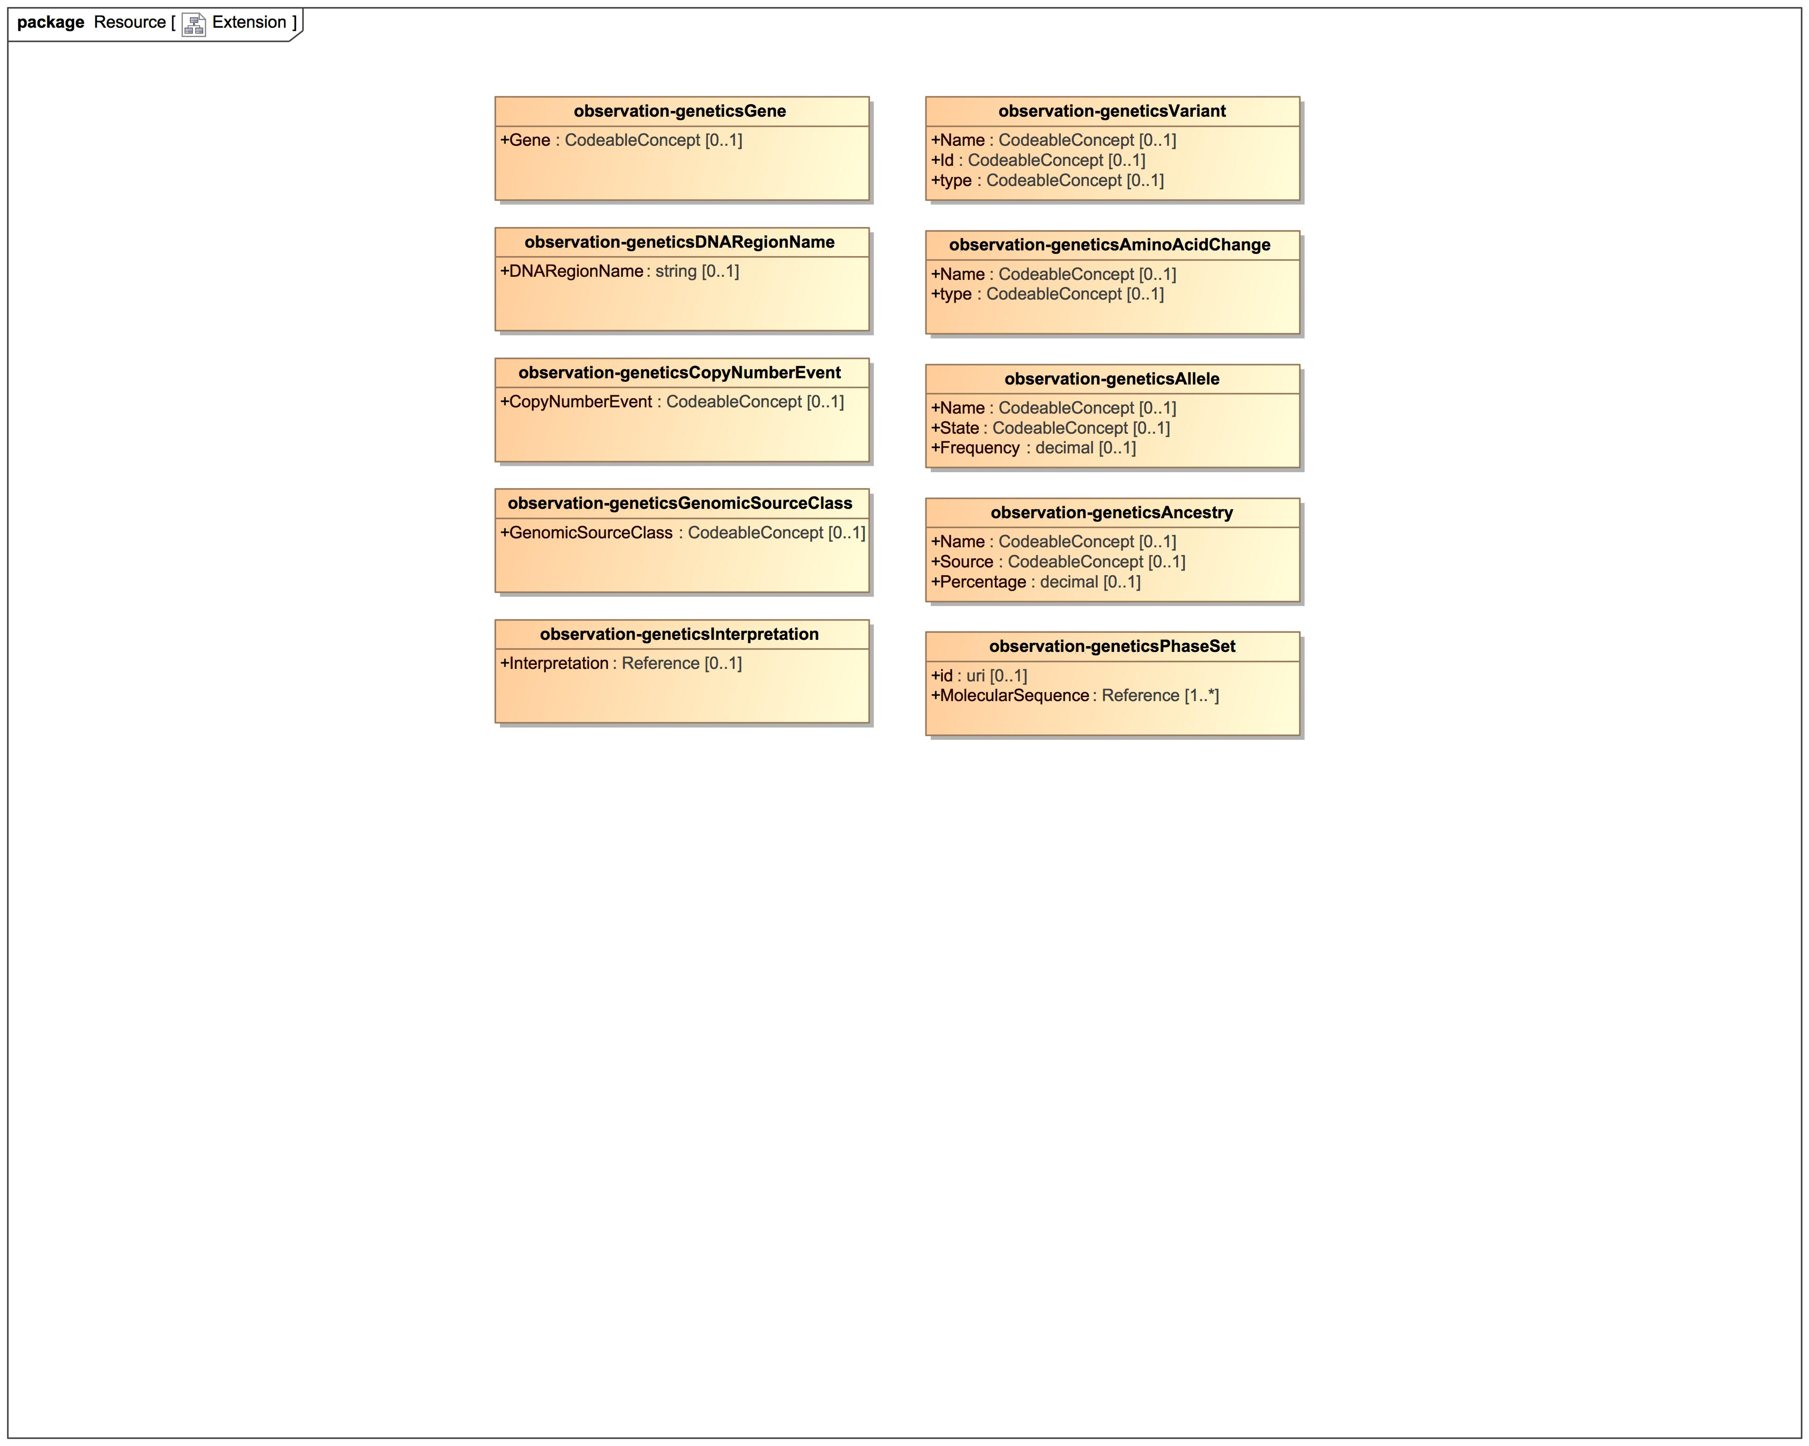

1. Extension

### Known other classes

Class observation-geneticsAllele, Class observation-geneticsAminoAcidChange, Class observation-geneticsAncestry, Class observation-geneticsCopyNumberEvent, Class observation-geneticsDNARegionName, Class observation-geneticsGene, Class observation-geneticsGenomicSourceClass, Class observation-geneticsInterpretation, Class observation-geneticsPhaseSet, Class observation-geneticsVariant

## Resource

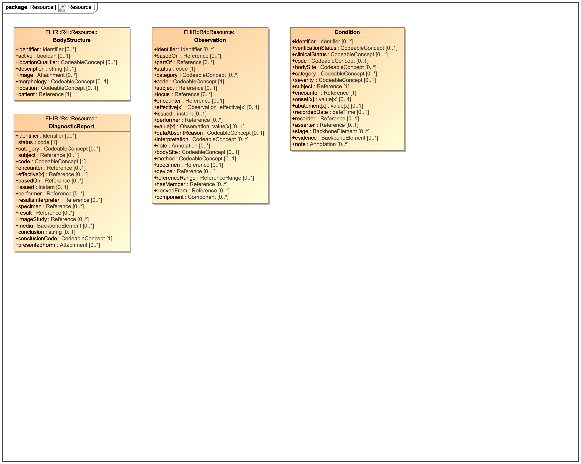

1. Resource

### Class BodyStructure

Specific and identified anatomical structure. Record details about an anatomical structure. This resource may be used when a coded concept does not provide the necessary detail needed for the use case. [Source: http://www.hl7.org/fhir/bodystructure.html]

#### Direct Known Superclasses

DomainResource

package FHIR::R4::Resource

public class BodyStructure

extends

DomainResource

#### Attributes

 public identifier : Identifier [0..*]

Bodystructure identifier

 public active : boolean [0..1]

Whether this record is in active use

 public locationQualifier : CodeableConcept [0..*]

Body site modifier

 public description : string [0..1]

Text description

 public image : Attachment [0..*]

Attached images

 public morphology : CodeableConcept [0..1]

Whether this record is in active use

 public location : CodeableConcept [0..1]

Whether this record is in active use

 public patient : Reference [1]

Whether this record is in active use

### Class Condition

A clinical condition, problem, diagnosis, or other event, situation, issue, or clinical concept that has risen to a level of concern.

#### Direct Known Superclasses

DomainResource

package FHIR::R4::Resource

public class Condition

extends

DomainResource

#### Attributes

 public identifier : Identifier [0..*]

Bodystructure identifier

 public verificationStatus : CodeableConcept [0..1]

Whether this record is in active use

 public clinicalStatus : CodeableConcept [0..1]

Body site modifier

 public code : CodeableConcept [0..1]

Text description

 public bodySite : CodeableConcept [0..*]

Attached images

 public category : CodeableConcept [0..*]

Whether this record is in active use

 public severity : CodeableConcept [0..1]

Whether this record is in active use

 public subject : Reference [1]

Whether this record is in active use

 public encounter : Reference [1]

Whether this record is in active use

 public onset[x] : value[x] [0..1]

Whether this record is in active use

 public abatement[x] : value[x] [0..1]

Whether this record is in active use

 public recordedDate : dateTime [0..1]

Whether this record is in active use

 public recorder : Reference [0..1]

Whether this record is in active use

 public asserter : Reference [0..1]

Whether this record is in active use

 public stage : BackboneElement [0..*]

Whether this record is in active use

 public evidence : BackboneElement [0..*]

Whether this record is in active use

 public note : Annotation [0..*]

Whether this record is in active use

### Class DiagnosticReport

The findings and interpretation of diagnostic tests performed on patients, groups of patients, devices, and locations, and/or specimens derived from these. The report includes clinical context such as requesting and provider information, and some mix of atomic results, images, textual and coded interpretations, and formatted representation of diagnostic reports.

#### Direct Known Superclasses

DomainResource

package FHIR::R4::Resource

public class DiagnosticReport

extends

DomainResource

#### Attributes

 public identifier : Identifier [0..*]

Business identifier for report

 public status : code [1]

registered | partial | preliminary | final +

 public catagory : CodeableConcept [0..*]

Service category

 public subject : Reference [0..1]

The subject of the report - usually, but not always, the patient

 public code : CodeableConcept [1]

What was requested

 public encounter : Reference [0..1]

Health care event when test ordered

 public effective[x] : Reference [0..1]

Whether this record is in active use

 public basedOn : Reference [0..*]

Whether this record is in active use

 public issued : instant [0..1]

 public performer : Reference [0..*]

 public resultsInterpreter : Reference [0..*]

 public specimen : Reference [0..*]

 public result : Reference [0..*]

 public imageStudy : Reference [0..*]

 public media : BackboneElement [0..*]

 public conclusion : string [0..1]

 public conclusionCode : CodeableConcept [1]

 public presentedForm : Attachment [0..*]

### Class Observation

Measurements and simple assertions made about a patient, device or other subject.

#### Direct Known Superclasses

DomainResource

package FHIR::R4::Resource

public class Observation

extends

DomainResource

#### Attributes

 public identifier : Identifier [0..*]

 public basedOn : Reference [0..*]

 public partOf : Reference [0..*]

 public status : code [1]

 public category : CodeableConcept [0..*]

 public code : CodeableConcept [1]

 public subject : Reference [0..1]

 public focus : Reference [0..*]

 public encounter : Reference [0..1]

 public effective[x] : Observation_effective[x] [0..1]

 public issued : instant [0..1]

 public performer : Reference [0..*]

 public value[x] : Observation_value[x] [0..1]

 public dataAbsentReason : CodeableConcept [0..1]

 public interpretation : CodeableConcept [0..*]

 public note : Annotation [0..*]

 public bodySite : CodeableConcept [0..1]

 public method : CodeableConcept [0..1]

 public specimen : Reference [0..1]

 public device : Reference [0..1]

 public referenceRange : ReferenceRange [0..*]

 public hasMember : Reference [0..*]

 public derivedFrom : Reference [0..*]

 public component : Component [0..*]

### Class Person

The Person resource serves as a linkage resource that may provide a reference set of common demographics for an individual (human or animal) across multiple roles. [Source: http://www.hl7.org/fhir/person.html]

package FHIR::R4::Resource

public class Person

#### Attributes

 public identifier : Identifier [0..*]

A human identifier for this person

 public gender : code [0..1]

male | female | other | unknown

 public birthDate : date [0..*]

The date on which the person was born

 public name : HumanName [0..*]

A name associated with the person

# PheWAS::Extension

## Extension

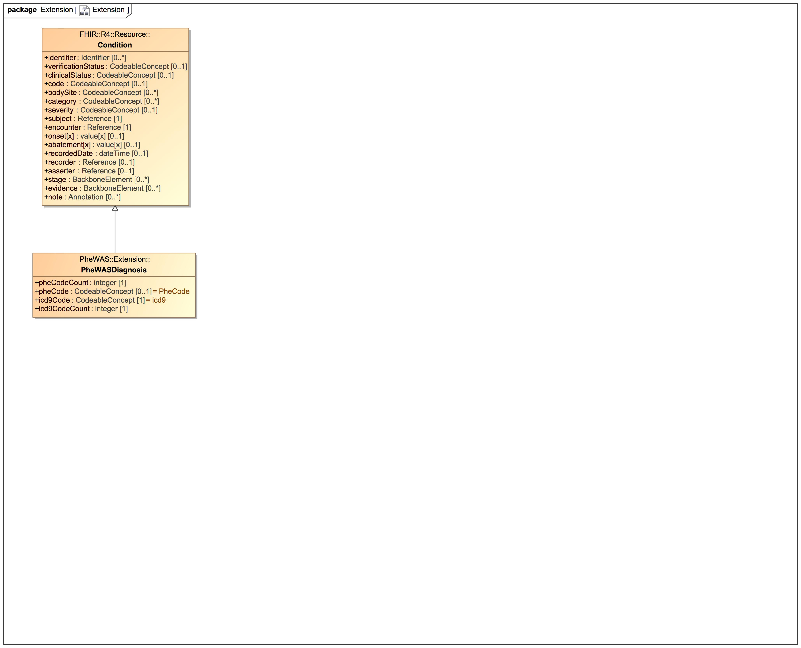

1. Extension

### Class PheWASDiagnosis

#### Direct Known Superclasses

Condition

package PheWAS::Extension

public class PheWASDiagnosis

extends

Condition

#### Attributes

 public pheCodeCount : integer [1]

 public pheCode : CodeableConcept [0..1] = PheCode

 public icd9Code : CodeableConcept [1] = icd9

 public icd9CodeCount : integer [1]

### Known other classes

Class Condition

# PheWAS::Model

## PheWASModel

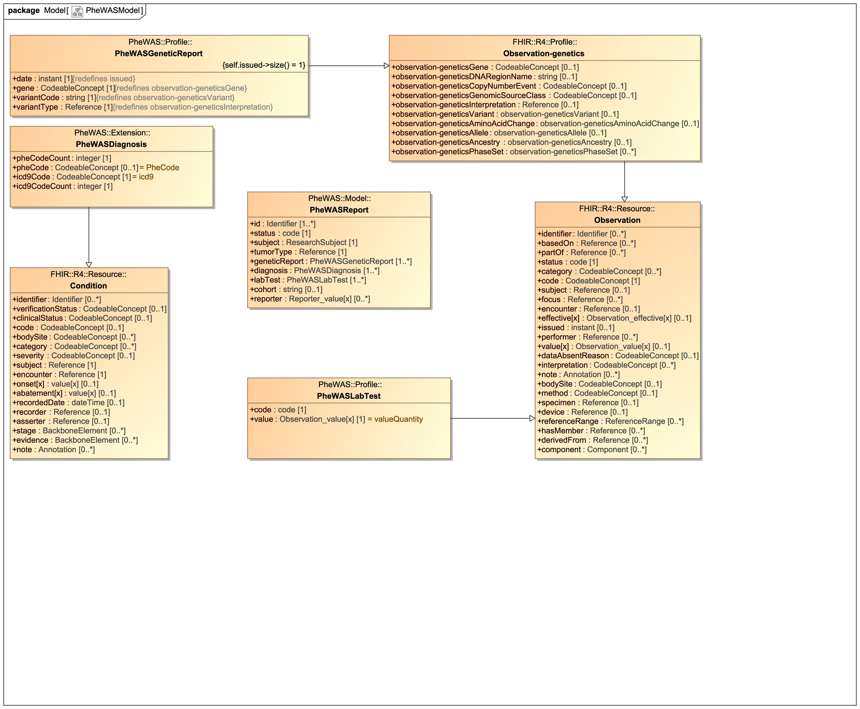

1. PheWASModel

### Class PheWASGeneticReport

#### Direct Known Superclasses

Observation-genetics

package PheWAS::Profile

public class PheWASGeneticReport

extends

Observation-genetics

#### Attributes

 public date : instant [1]

 public gene : CodeableConcept [1]

 public variantCode : string [1]

 public variantType : Reference [1]

### Class PheWASLabTest

#### Direct Known Superclasses

Observation

package PheWAS::Profile

public class PheWASLabTest

extends

Observation

#### Attributes

 public code : code [1]

 public value : Observation_value[x] [1] = valueQuantity

### Class PheWASReport

package PheWAS::Model

public class PheWASReport

#### Attributes

 public id : Identifier [1..*]

 public status : code [1]

 public subject : ResearchSubject [1]

 public tumorType : Reference [1]

 public geneticReport : PheWASGeneticReport [1..*]

 public diagnosis : PheWASDiagnosis [1..*]

 public labTest : PheWASLabTest [1..*]

 public cohort : string [0..1]

 public reporter : Reporter_value[x] [0..*]

#### Associations

 public : Coding [0..*]

A reference to a code defined by a terminology system.  
A Coding is a representation of a defined concept using a symbol from a defined "code system" [Source: https://www.hl7.org/fhir/datatypes.html#coding]

 public : Coding [0..*]

A reference to a code defined by a terminology system.  
A Coding is a representation of a defined concept using a symbol from a defined "code system" [Source: https://www.hl7.org/fhir/datatypes.html#coding]

### Known other classes

Class Condition, Class Observation, Class Observation-genetics, Class PheWASDiagnosis

# PheWAS::Profile

## Profile

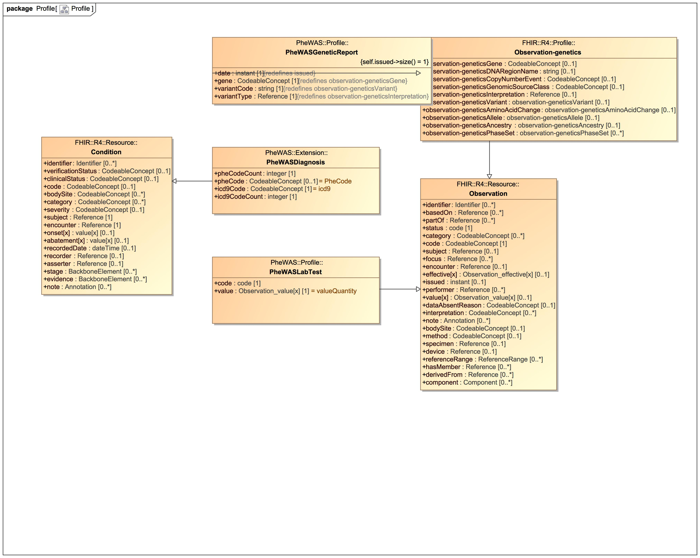

1. Profile

### Known other classes

Class Condition, Class Observation, Class Observation-genetics, Class PheWASDiagnosis, Class PheWASGeneticReport, Class PheWASLabTest

# PheWAS::ValueSet

## ValueSet

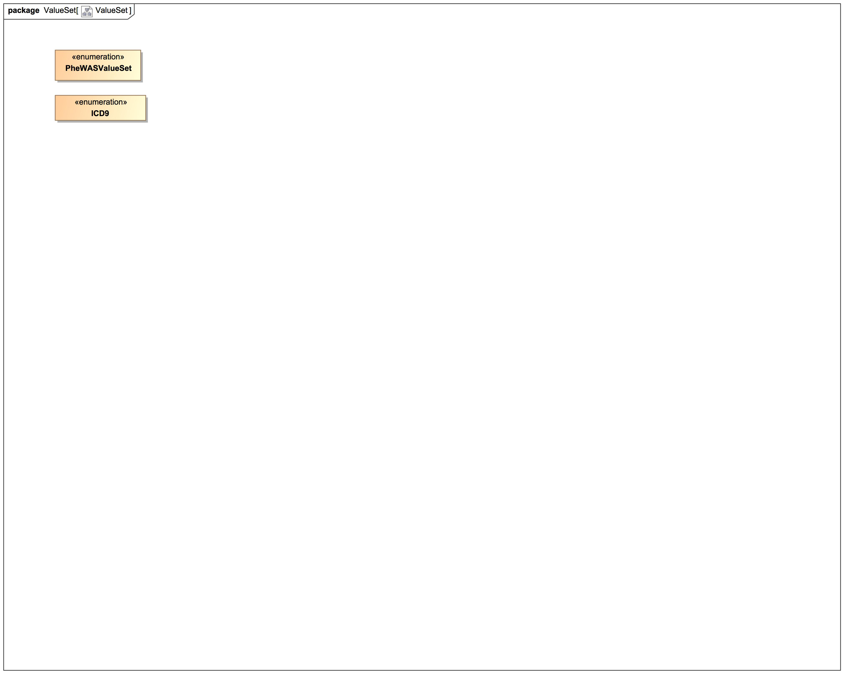

1. ValueSet

### Enumeration ICD9

package PheWAS::ValueSet

public enum ICD9

### Enumeration PheWASValueSet

package PheWAS::ValueSet

public enum PheWASValueSet

# Tree

## Class Hierarchy

## Enumeration Hierarchy